*Florida International University*

*School of Computing and Information Sciences*

CEN 5011: Advance Software Engineering, Fall 2016

Final Deliverable

Project Title: Social Application Version 1.0

**Team Members:**

Shamsed Mahmud

Sirisha Singaraju

**Product Owner(s)**:

Rick Little

**Mentor(s)**:

Mohsen Taheri

**Instructor**:

Masoud Sadjadi

The MIT License (MIT)

Copyright (c) *2016 Florida International University*

Permission is hereby granted, free of charge, to any person obtaining a copy of this software and associated documentation files (the "Software"), to deal in the Software without restriction, including without limitation the rights to use, copy, modify, merge, publish, distribute, sublicense, and/or sell copies of the Software, and to permit persons to whom the Software is furnished to do so, subject to the following conditions:

The above copyright notice and this permission notice shall be included in all copies or substantial portions of the Software.

THE SOFTWARE IS PROVIDED "AS IS", WITHOUT WARRANTY OF ANY KIND, EXPRESS OR IMPLIED, INCLUDING BUT NOT LIMITED TO THE WARRANTIES OF MERCHANTABILITY, FITNESS FOR A PARTICULAR PURPOSE AND NONINFRINGEMENT. IN NO EVENT SHALL THE AUTHORS OR COPYRIGHT HOLDERS BE LIABLE FOR ANY CLAIM, DAMAGES OR OTHER LIABILITY, WHETHER IN AN ACTION OF CONTRACT, TORT OR OTHERWISE, ARISING FROM, OUT OF OR IN CONNECTION WITH THE SOFTWARE OR THE USE OR OTHER DEALINGS IN THE SOFTWARE.

***Abstract***

*This document presents the information necessary to gain a good understanding of the Social Application Version 1.0 project. The Social Application Version 1.0 project is a dynamic web based and Android mobile app that helps E-SToPP organization’s manager to administer official activities and the user to manage different forms to ease application process and get informed up to date about present information and activities of the organization. In the following pages, user stories, diagrams and information will be presented that will describe the project in detail.*

**Table of Contents**

**Introduction** ……………………………………………………………………………………………………………………………….. 5

Current System ………………………………………………………………………………………………………………………... 6

Purpose of New System ……………………………………………………………………………………………………………... 6

**User Stories**

Implemented User Stories …………………………………………………………………………………………………………..7

Pending User Stories …………………………………………………………………………………………………………..….. 19

**Project Plan**

Hardware and Software Resources ………………………………………………………………………………………….… 20

Sprints Plan ……………………………………………………………………………………………………………………… 22

*Sprint 1*  …………………………………………………………………………………………………………………………... 22

*Sprint 2*  …………………………………………………………………………………………………………………………... 23

*Sprint 3*  …………………………………………………………………………………………………………………………... 23

*Sprint 4*  …………………………………………………………………………………………………………………………... 24

*Sprint 5*  …………………………………………………………………………………………………………………………... 25

*Sprint 6*  …………………………………………………………………………………………………………………………... 26

*Sprint 7*  …………………………………………………………………………………………………………………………... 27

**System Design**

Architectural Patterns ………………………………………………………………………………………………………….. 27

System and Subsystem Decomposition ……………………………………………………………………………………….… 28

Deployment Diagram ………………………………………………………………………………………………………….…... 30

Design Patterns ……………………………………………………………………………………………………………….….... 31

**System Validation**  …………………………………………………………………………………………………………………….31

**Glossary**  ………………………………………………………………………………………………………………………………….50

**Appendix**  ………………………………………………………………………………………………………………………………….51

Appendix A - UML Diagrams ……………………………………………………………………………………………………. 55

*Static UML Diagrams*  ……………………………………………………………………………………………………….56

*Dynamic UML Diagrams*  …………………………………………………………………………………………………..

Appendix B - User Interface Design ……………………………………………………………………………………….…... 103

Appendix C - Sprint Review Reports ……………………………………………………………………………………...……………………………………………………132

Appendix D - User Manuals, Installation/Maintenance Document, Shortcomings/Wishlist Document and other documents …………………………………………………………………….…………………...137

**References** ……………………………………………………………………………………………………………………...… 143

**Introduction**

E-SToPP is a 501(c)3 not-for-profit organization dedicated to eradicating the school-to-prison pipeline throughout southeastern Florida’s most economically disadvantage communities by building a grass-roots network of transformative schools and educational opportunities for underserved and unserved youth. It has a website which is almost static one. So, their management decided to add some functionality to it and create a mobile application of the remodeled website.

## 

## Current System

## The current system has only a static website. It has some pdf form to work for application. The website doesn’t have functionality to store data in database. It doesn’t have mail campaign option. Moreover, there is no mobile application of this website.

## Purpose of New System

The purpose of the new system is to add some functionality to the website regarding converting it a dynamic website with some new features like dynamic web enable forms, Search options within website, make a more beautiful animation feature and its mobile application.

# User Stories

The following section provides the detailed user stories that were implemented in this iteration of the Social Application Version 1.0 project. These user stories served as the basis for the implementation of the project’s features. This section also shows the user stories that are to be considered for future development.

## Implemented User Stories

# User Story [#89](https://fiu-scis-seniorproject.mingle.thoughtworks.com/projects/social_app/cards/89) Application Launch

### Description:

* As a user, I want to launch the E-SToPP app from an android smart phone so that I can see the homepage.

### Acceptance Criteria:

1. Home page button is present on the smart phone
2. icon is active
3. selection of the icon launches the E-SToPP app

**UML DIAGRAM IN CORRESPONDING APPENDIX A USER STORY SECTION**

# User Story [#120](https://fiu-scis-seniorproject.mingle.thoughtworks.com/projects/social_app/cards/120) testing of home and blog features of app

### Description:

* The e-stopp app’s functionality of home and blog needs to be tested before deployment

### Acceptance Criteria:

1. all the content in different tabs must be visible
2. the navigation from one tab to other must be easy and prompt

**UML DIAGRAM IN CORRESPONDING APPENDIX A USER STORY SECTION**

# User Story [#121](https://fiu-scis-seniorproject.mingle.thoughtworks.com/projects/social_app/cards/121) testing of calendar and contact features

### Description:

* testing of calendar and contact needs to be completed as per android launch checklist

### Acceptance Criteria:

1. the content should be properly visible on clicking on each tab
2. the navigation from one tab to other must be easy and prompt

**UML DIAGRAM IN CORRESPONDING APPENDIX A USER STORY SECTION**

# User Story [#122](https://fiu-scis-seniorproject.mingle.thoughtworks.com/projects/social_app/cards/122) deployment of app in google play

### Description:

* e-stopp app can perform in google play

### Acceptance Criteria:

1. app should be in google play

**UML DIAGRAM IN CORRESPONDING APPENDIX A USER STORY SECTION**

# User Story [#123](https://fiu-scis-seniorproject.mingle.thoughtworks.com/projects/social_app/cards/123) Performance Enhancement and Progress baR

### Description:

* We need to implement Progress bar and performance enhancement of the mobile app

### Acceptance Criteria:

1. Whenever we start the app it will work faster
2. Whenever we will go into new doc then it will show progress bar

**UML DIAGRAM IN CORRESPONDING APPENDIX A USER STORY SECTION**

# User Story [#125](https://fiu-scis-seniorproject.mingle.thoughtworks.com/projects/social_app/cards/125) Add email functionality to contact-us in e-stopp webpage

### Description:

* the contact us form on e-stopp website should send emails to appropriate email ids

### Acceptance Criteria:

1. the email must be in its original form without any form of distortion or tampering
2. the email should not go to the spam folder of the receiver

**UML DIAGRAM IN CORRESPONDING APPENDIX A USER STORY SECTION**

# User Story [#126](https://fiu-scis-seniorproject.mingle.thoughtworks.com/projects/social_app/cards/126) Add the get-in touch Mail Chimp form

### Description:

* A new ‘get-in touch’ plugin needs to be added to the e-stopp website and integrated with mail chimp

### Acceptance Criteria:

1. It can send user name, e-mail and message to MailChimp repository.
2. the new form must be give different message according to user storage on the MailChimp Repository

**UML DIAGRAM IN CORRESPONDING APPENDIX A USER STORY SECTION**

User Story[#127](https://fiu-scis-seniorproject.mingle.thoughtworks.com/projects/social_app/cards/127)**Convert the Volunteer Application Form in Interactive Website with Wordpress-1(Page 1&2 of PDF)**

### Description:

* You have to convert the Volunteer Application Form of first two pages which is now a four page pdf file into interactive web pages and the form should send information to e-stopp.org administrator. The user should provide name, email, cell and address information and can send into database.

### Acceptance Criteria:

1. The form should be responsive website
2. The form should be converted in the mobile application also
3. It should get name,cell,phone number and address correctly.
4. It should also save all those information and generate an email to be sent to e-stopp mail.

**UML DIAGRAM IN CORRESPONDING APPENDIX A USER STORY SECTION**

# User Story [#128](https://fiu-scis-seniorproject.mingle.thoughtworks.com/projects/social_app/cards/128) Convert the Volunteer Application Form in Interactive Website with Wordpress-2(Page 3&4 of PDF)

### Description:

* You have to convert the Volunteer application form (page 3 and 4) into responsive website using wordpress which is now a four page pdf document and convert the responsive website into mobile application development and some field must have some checking option. The user could select any of the option of volunteer application form and they should provide signature and date accordingly and send into database.

### Acceptance Criteria:

1. The Volunteer application form should be responsive in WordPress.
2. The application form should be a part of mobile application.
3. The plugin for storing the data entered in the form must be functioning properly.
4. The checkbox, user signature and date should be verified and store in database.

**UML DIAGRAM IN CORRESPONDING APPENDIX A USER STORY SECTION**

# User Story [#129](https://fiu-scis-seniorproject.mingle.thoughtworks.com/projects/social_app/cards/129) Convert the pdf of Transformative Research form in e-StoPP website to responsive website and convert to mobile application

### Description:

* I need to convert the pdf of  Trans formative Research form into Responsive website form and convert the responsive website to mobile application.

### Acceptance Criteria:

1. Trans formative Research form should be responsive
2. The form should be available on mobile application
3. The form data should be stored in contact db
4. There should be validations for wrong input

**UML DIAGRAM IN CORRESPONDING APPENDIX A USER STORY SECTION**

# User Story [#130](https://fiu-scis-seniorproject.mingle.thoughtworks.com/projects/social_app/cards/130) Convert the pdf of Transformative Education center form in e-StoPP website to a responsive website and convert to mobile application

### Description:

* I have to convert the Trans-formative Education center form, from pdf to responsive website and convert into mobile application. So that I can enter the information of form in the website or mobile application which would save into corresponding contact db database.  Apart from this task we have to replace Communication and Social media form with previous PPLM form modified according to requirement  which we did in sprint 4.

### Acceptance Criteria:

1. Trans-formative Education center form should be converted to responsive website form
2. The form should be available to in mobile application
3. The following form field should have checking criteria
4. It should have related message according to wrong input in the fields.
5. Apart from this task I have to convert the Communication and Social media form with previous PPLM form modified according to requirements.

**UML DIAGRAM IN CORRESPONDING APPENDIX A USER STORY SECTION**

# User Story  [#131](https://fiu-scis-seniorproject.mingle.thoughtworks.com/projects/social_app/cards/131) Add a new 'Transformative Schools' Image with graphics and animation for the main Banner for e-Stopp Website

### Description:

* Create a new image with animation and graphics to be added to the e-stopp banner on the home page

### Acceptance Criteria:

1. The image should look similar to the previous one in font and style.
2. it should load correctly in the website and link correctly to ‘Transformative Schools’ Webpage
3. It should work properly on the app too.

**UML DIAGRAM IN CORRESPONDING APPENDIX A USER STORY SECTION**

# User Story  [#132](https://fiu-scis-seniorproject.mingle.thoughtworks.com/projects/social_app/cards/132) Convert the pdf of Transformative Praxis center form in e-StoPP website to a responsive website and convert to mobile application

### Description:

* I have to convert the Trans-formative Praxis center form, from pdf to responsive website and convert into mobile application. So that I can enter the information of form in the website or mobile application which would save into corresponding contact db database.

### Acceptance Criteria:

1. Trans-formative Education center form should be converted to responsive website form
2. The form should be available to in mobile application
3. The following form field should have checking criteria
4. It should have related message according to wrong input in the fields.

**UML DIAGRAM IN CORRESPONDING APPENDIX A USER STORY SECTION**

# User Story  [#133](https://fiu-scis-seniorproject.mingle.thoughtworks.com/projects/social_app/cards/133) Adding AJAX powered Search Lite to the e-Stopp website

### Description:

* A new search panel has to be added to the home page of the e-stopp website. It should search individually on each category as well as the whole website. It should feature a drop down menu. It should be reflected on the app as well

### Acceptance Criteria:

1. The search should function correctly and give accurate results
2. The search panel should be themed similarly to the rest of the website
3. If the user click on the search engine then the corresponding page will be shown which reflect the app too.

**UML DIAGRAM IN CORRESPONDING APPENDIX A USER STORY SECTION**

# User Story  [#134](https://fiu-scis-seniorproject.mingle.thoughtworks.com/projects/social_app/cards/134) Adding Instagram icon and linking the account to the Website

### Description:

* Instagram icon should be placed in the appropriate place next to other social media icon and it should be linked to e-stopp’s instagram account. The changes should get reflected in mobile app too

### Acceptance Criteria:

1. The icon should be places in the correct position ie. next to facebook and twitter one
2. The icon should be linked to correct account.

**UML DIAGRAM IN CORRESPONDING APPENDIX A USER STORY SECTION**

# User Story[#135](https://fiu-scis-seniorproject.mingle.thoughtworks.com/projects/social_app/cards/135) Add a new 'Positive Peers' Image with graphics and animation for the main Banner for e-Stopp Website

### Description:

* Create a new image with animation and graphics to be added to the e-stopp banner on the home page

### Acceptance Criteria:

1. The image should look similar to the previous one in font and style.
2. it should load correctly in the website and link correctly to ‘Transformative Schools’ Webpage
3. It should work properly on the app too.

**UML DIAGRAM IN CORRESPONDING APPENDIX A USER STORY SECTION**

# User Story [#136](https://fiu-scis-seniorproject.mingle.thoughtworks.com/projects/social_app/cards/136) Add a new Mail Chimp Account, Import Data and a Campaign for e-stopp website

### Description:

* To add a MailChimp Account ( Administrator ), Import data from existing other users user and add a campaign form in Mail chimp account to send notifications to all e-stopp users.

### Acceptance Criteria:

1. To add MailChimp account form for e-stopp website.
2. To add all users imported from existing accounts to the newly created form
3. To add a campaign in MailChimp account.
4. The form should function correctly and send information to all users

**UML DIAGRAM IN CORRESPONDING APPENDIX A USER STORY SECTION**

**User Story #137** Create Poster and Documentation of the Project

### Description:

* Create a poster
* Create a power point presentation
* Create a final document
* Create four video regrading creation, installation, guideline and remaining task
* Upload to GIt

### Acceptance Criteria:

1. All documentation should be done according to guideline
2. All Video should be done in corresponding guideline

**UML DIAGRAM IN CORRESPONDING APPENDIX A USER STORY SECTION**

**User Story #138** Create Poster and Documentation of the Project

### Description:

* Create a poster
* Create a power point presentation
* Create a final document
* Create four video regrading creation, installation, guideline and remaining task
* Upload to GIt

### Acceptance Criteria:

1. All documentation should be done according to guideline
2. All Video should be done in corresponding guideline

**UML DIAGRAM IN CORRESPONDING APPENDIX A USER STORY SECTION**

## 

## Pending User Stories

In our task there is no pending user stories.

# Project Plan

This section describes the planning that went into the realization of this project. This project incorporated the agile development techniques and as such required the sprints to be planned. This sprint planning’s are detailed in the section. This section also describes the components, both software and hardware, chosen for this project.

## Hardware and Software Resources

The following is a list of all hardware and software resources that were used in this project:

**Mingle**

Mingle was used as a planning and management tool for the various agile development processes

**PHP**

PHP programming language is used for programming server side script.

**Java**

Android programming language is java

**JavaScript**

Java Script is used to client side programming

**MySQL**

Local and portable database for mobile devices

**Android**

OS available in Android phones

**HTML AND CSS**

Designing User Interface

**Git**

Repository hosting service, provides access control and several collaboration features

## 

## 

## Sprints Plan

***Sprint 1***

Attendees: Rick Little, Shamsed Mahmud , Sirisha Singaraju

Start time: 08.23.2016 03:00 PM

End time: 08.23..2016  05:00 PM

After discussion, the velocity of the team were estimated to be <Enter the estimated team velocity>.

The product owner chose the following user stories to be done during the next sprint. They are ordered based on their priority.

* User Story [#108](https://fiu-scis-seniorproject.mingle.thoughtworks.com/projects/social_app/cards/108) Sample Story 1 (b)
* User Story[#119](https://fiu-scis-seniorproject.mingle.thoughtworks.com/projects/social_app/cards/119) Study E-SToPP

The team members indicated their willingness to work on the following user stories.

* <Shamsed Mahmud>
* User Story[#119](https://fiu-scis-seniorproject.mingle.thoughtworks.com/projects/social_app/cards/119) Study E-SToPP

* <Sirisha Singaraju>
  + User Story[#119](https://fiu-scis-seniorproject.mingle.thoughtworks.com/projects/social_app/cards/119) Study E-SToPP

### Sprint 2

Attendees: Rick Little, Shamsed Mahmud , Sirisha Singaraju

Start time: 08.31.2016 03:00 PM

End time: 08.31.2016  05:00 PM

After discussion, the velocity of the team were estimated to be <Enter the estimated team velocity>.

The product owner chose the following user stories to be done during the next sprint. They are ordered based on their priority.

* User Story <118 and Display E-SToPP HomePage>
* User Story<117 and E-SToPP Icon >

The team members indicated their willingness to work on the following user stories.

* <Shamsed Mahmud>
* User Story <118 and Display E-SToPP HomePage>
* It has 11 out of which 8  layer (1,2,4,5,6,7,8)

* <Sirisha Singaraju>
  + User Story <118 and Display E-SToPP HomePage>
  + It has 11 layer out of which 3 layer (3,9,10,11)
  + User Story<117 and E-StoPP Icon>

### 

### Sprint 3

Attendees: Rick Little, Shamsed Mahmud , Sirisha Singaraju

Start time: 09.29.2016 at 03:00 PM

End time: 09.29.2016  at 04:00 PM

After discussion, the velocity of the team were estimated to be 40

The product owner chose the following user stories to be done during the next sprint. They are ordered based on their priority.

* User Story <125> Add email functionality to contact us page of e-stopp website
* User Story <126> Add new ‘get in touch’ using the mailchimp plugin

The team members indicated their willingness to work on the following user stories.

* <Shamsed Mahmud>
* User Story <126> Add new ‘get in touch’ using the mailchimp plugin in e-SToPP website

* <Sirisha Singaraju>
  + User Story <125> Add email functionality to contact us page of e-stopp website

***Sprint 4***

Attendees: Rick Little, Shamsed Mahmud , Sirisha Singaraju

Start time: 10.11.2016 at 03:00 PM

End time: 10.11.2016  at 04:00 PM

After discussion, the velocity of the team were estimated to be 40

The product owner chose the following user stories to be done during the next sprint i.e Sprint 4. They are ordered based on their priority.

* User Story <127> Convert the Volunteer Application Form in Interactive Website with Wordpress-1(Page 1&2)
* User Story <128> Convert the Volunteer Application Form in Interactive Website with Wordpress-2(Page 3&4)

The team members indicated their willingness to work on the following user stories.

* <Sirisha Singaraju>
* User Story <127> Convert the Volunteer Application Form in Interactive Website with Wordpress-1(Page 1&2) and send form information in email to E-Stopp
* <Shamsed Mahmud>
  + User Story <128> Convert the Volunteer Application Form in Interactive Website with Wordpress-2(Page 3&4) and store form information in Contact Form Db.

***Sprint 5***

Attendees: Rick Little, Shamsed Mahmud , Sirisha Singaraju

Start time: 10.24.2016 at 03:00 PM

End time: 10.24.2016  at 04:00 PM

After discussion, the velocity of the team were estimated to be 40

The product owner chose the following user stories to be done during the next sprint i.e Sprint 5. They are ordered based on their priority.

* User Story <129> Convert the pdf of Transformative Research form in e-StoPP website to responsive website and convert to mobile application.
* User Story <130> Convert the pdf of Transformative Education center form in e-StoPP website to a responsive website and convert to mobile application.
* User Story <131> Add a new 'Transformative Schools' Image with graphics and animation for the main Banner for e-Stopp Website
* User Story <132> Convert the pdf of Trans-formative Praxis center form in e-StoPP website to a responsive website and convert to mobile application.

The team members indicated their willingness to work on the following user stories.

* <Sirisha Singaraju>
* User Story <129> Convert the pdf of Transformative Research form in e-StoPP website to responsive website and convert to mobile application.
* User Story <131> Add a new 'Transformative Schools' Image with graphics and animation for the main Banner for e-Stopp Website
* <Shamsed Mahmud>
  + User Story <130> Convert the pdf of Transformative Education center form in e-StoPP website to a responsive website and convert to mobile application.
  + User Story <132> Convert the pdf of Trans-formative Praxis center form in e-StoPP website to a responsive website and convert to mobile application

***Sprint 6***

Attendees: Rick Little, Shamsed Mahmud , Sirisha Singaraju

Start time: 11.08.2016 at 03:00 PM

End time: 11.08.2016  at 04:00 PM

After discussion, the velocity of the team were estimated to be 40

The product owner chose the following user stories to be done during the next sprint i.e Sprint 5. They are ordered based on their priority.

* User Story <133> Adding AJAX powered Search Lite to the e-Stopp website .
* User Story <134> Adding Instagram icon and linking the account to the Website
* User Story <135> Add a new 'Positive Peers' Image with graphics and animation for the main Banner for e-Stopp Website
* User Story <136> Add a new MailChimp Account, Import Data and a Campaign for e-stopp website

The team members indicated their willingness to work on the following user stories.

* <Sirisha Singaraju>
* User Story <134> Adding Instagram icon and linking the account to the Website
* User Story <135> Add a new 'Positive Peers' Image with graphics and animation for the main Banner for e-Stopp Website
* <Shamsed Mahmud>
  + User Story <133> Adding AJAX powered Search Lite to the e-Stopp website .
  + User Story <136> Add a new MailChimp Account, Import Data and a Campaign for e-stopp website

***Sprint 7***

Attendees: Mohsen Taheri, Shamsed Mahmud , Sirisha Singaraju

Start time: 11.21.2016 at 03:00 PM

End time: 11.21.2016  at 04:00 PM

After discussion, the velocity of the team were estimated to be 40

The product owner chose the following user stories to be done during the next sprint i.e Sprint 5. They are ordered based on their priority.

* User Story <137> Create Poster and Documentation of the Project.
* User Story <138> Create Poster and Documentation of the Project

The team members indicated their willingness to work on the following user stories.

* <Sirisha Singaraju>
* User Story <138> Create Poster and Documentation of the Project
* <Shamsed Mahmud>
  + User Story <137> Create Poster and Documentation of the Project.

# System Design

This section contains information on the design decisions that went into this project. The architecture patterns are outlined and explained. The entire system is shown in a package diagram and the subsystems are explained. Finally, the design patterns used in the project are discussed.

## Architectural Patterns

This project uses a cross-platform 3-tier architecture. The presentation layer was split between the three devices while the business, and data layer was together as part of a shared codebase. The following diagram illustrates this cross-platform architecture.

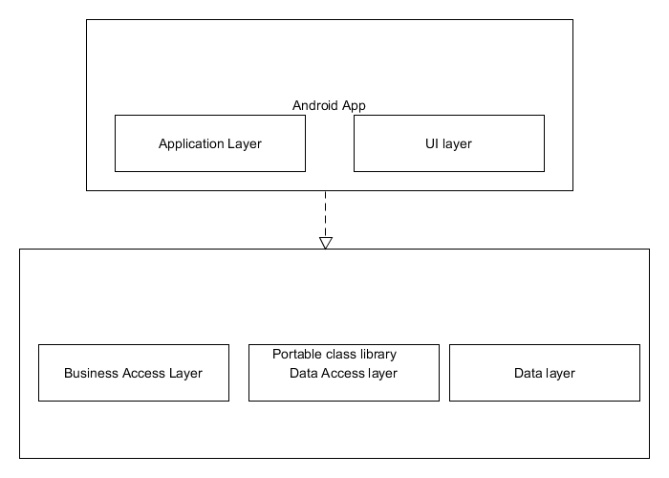

## 

## Deployment Diagram (Client Server Model )

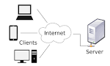

## Design Patterns

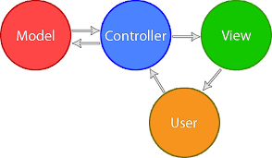**System Validation**

In this section, all of the test cases that were down to validate our system are outlined. All of the testing was done manually, following the input requirements of test cases.

**Unit Test** & **Integration Test:**

|  |
| --- |
| **Test Id:#89-TC01** |
| **Purpose:**If you run the application in any Android device or emulator you will launch the application |
| **Precondition:** The App need to be run |
| **Input:** Run the application |
| **Expected Result:** You will View the App |

|  |
| --- |
| **Test Id: Testing#120-TC001** |
| **Purpose:** If I launch the application it will show the homepage and all information clearly. |
| **Precondition:**   * Whenever the program runs the app’s homepage should  looks correctly. |
| **Input:**   * Run the app and scroll through the home page |
| **Expected Result**   * True |

|  |
| --- |
| **Test Id:Testing#120-TC002** |
| **Purpose:**If I click on the Home button then the corresponding page shows clearly. |
| **Precondition:**   * The app must be run on any android device |
| **Input:**   * Click the Home button |
| **Expected Result**   * Ok |

|  |
| --- |
| **Test Id:Testing#120-TC003** |
| **Purpose:**If I click on the  Blog button then the corresponding page shows clearly. |
| **Precondition:**   * The app must be run on any android device |
| **Input:**   * Click the Blog button |
| **Expected Result**   * Ok |

|  |
| --- |
| **Test Id:Testing#120-TC004** |
| **Purpose:**If I click on the Calendar button then the corresponding page shows clearly. |
| **Precondition:**   * The app must be run on any android device |
| **Input:**   * Click the Calendar button |
| **Expected Result**   * Ok |

|  |
| --- |
| **Test Id:Testing#120-TC005** |
| **Purpose:**If I click on the Contact button then the corresponding page shows clearly. |
| **Precondition:**   * The app must be run on any android device |
| **Input:**   * Click the Contact button |
| **Expected Result**   * Ok |

|  |
| --- |
| **Test Id:Testing#120-TC006** |
| **Purpose:**If I click on the Donate button then the corresponding page shows clearly |
| **Precondition:**   * The app must be run on any android device |
| **Input:**   * Click the Donate button |
| **Expected Result**   * Donate information page appear |

|  |
| --- |
| **Test Id:Testing#120-TC007** |
| **Purpose:**If I click on the Subscribe button then the corresponding Text Field mail disappear and get a mail |
| **Precondition:**   * The app must be run on any android device |
| **Input:**   * The mail address and then click |
| **Expected Result**   * Ok |

|  |
| --- |
| **Test Id:Testing#120-TC008** |
| **Purpose:**If I put invalid email address and push on the Subscribe button then please enter a valid email address will appear. |
| **Precondition:**   * The app must be run on any android device |
| **Input:**   * The wrong mail address and then click subscribe |
| **Expected Result**   * Ok |

|  |
| --- |
| **Test Id:Testing#120-TC009** |
| **Purpose:**If I click on the send button of Get in Touch then the corresponding message will send to the mail address. And the input Text Box will be null. |
| **Precondition:**   * The app must be run on any android device * The email should be subscribe before via subscribe button |
| **Input:**   * Put your Name , E-mail and message and click send button |
| **Expected Result**   * It will send and does accordingly |

|  |
| --- |
| **Test Id:Testing#120-TC010** |
| **Purpose:**If I put invalid data in any of the field and click on the send button of Get in Touch then it will reply please input correct input. |
| **Precondition:**   * The app must be run on any android device * The email should be subscribe before via subscribe button |
| **Input:**   * Put your Name , E-mail and message and click invalid address and click send button |
| **Expected Result**   * It will say please input valid data |

|  |
| --- |
| **Test Id:Testing#120-TC011** |
| **Purpose:**If I click on BLOG page then it will go the Blog page. |
| **Precondition:** Users need to enter into the Home page |
| **Input:** The click or touch the BloG Button. |
| **Expected Result** It will move into blog page |

|  |
| --- |
| **Test Id:Testing#120-TC012** |
| **Purpose:**In the BLOG page if we click on facebook, Tweeter, google then it will move into the corresponding pages |
| **Precondition:** The user need to go into the Blog page |
| **Input:** The click and touch button |
| **Expected Result** The move into the new corresponding page |

|  |
| --- |
| **Test Id:Testing#120-TC013** |
| **Purpose:**In the Mobile the Back button press give us to the back page |
| **Precondition:** You have to be in the App |
| **Input:** Click in the back button |
| **Expected Result:** Go to the back Button if the there is no back it will finish from the program |

|  |
| --- |
| **Test Id: Testing#120-TC001** |
| **Purpose:** If I launch the application it will show the homepage and all information related to  Calendar and Contact clearly. |
| **Precondition:**   * Whenever the program runs the app’s homepage should  looks correctly. * Calendar and Contact page should work correctly |
| **Input:**   * Run the app and click on Calendar page |
| **Expected Result**   * Calendar page loads correctly- Working OK |

|  |
| --- |
| **Test Id:Testing#120-TC002** |
| **Purpose:**If I use the search bar to search on calendar page it shows proper results. |
| **Precondition:**   * The page must be running on any android device |
| **Input:**   * Enter any string in search bar |
| **Expected Result**   * Relevant information shows up - Working OK |

|  |
| --- |
| **Test Id:Testing#120-TC003** |
| **Purpose:**If I click on the  Contact button then the corresponding page shows clearly. |
| **Precondition:**   * The app must be run on any android device |
| **Input:**   * Click the Contact button |
| **Expected Result**   * The Contact Page shows up - Working OK |

|  |
| --- |
| **Test Id:Testing#120-TC004** |
| **Purpose:**If I click on the Donate button then the corresponding page shows clearly |
| **Precondition:**   * The app must be run on any android device |
| **Input:**   * Click the Donate button |
| **Expected Result**   * Donate information page appear -Working OK |

|  |
| --- |
| **Test Id:Testing#120-TC005** |
| **Purpose:**If I put invalid data in any of the field and click on the send button of Get in Touch then it will reply please input correct input. |
| **Precondition:**   * The app must be run on any android device * The email should be subscribe before via subscribe button |
| **Input:**   * Put your Name , E-mail and message and enter any  invalid address and click send button |
| **Expected Result**   * It will say please input valid data -Working OK |

|  |
| --- |
| **Test Id: Testing#123-TC001** |
| **Purpose:** If I launch the application it will show promptly |
| **Precondition:**   * The user should be in the App * The App should be in the running state |
| **Input:**   * Run the app and hover between different buttons |
| **Expected Result**   * True |

|  |
| --- |
| **Test Id:Testing#123-TC002** |
| **Purpose:**If I click on any button before starting the corresponding page it show progress Bar |
| **Precondition:**   * The app must be run on any android device * The user should be in the App |
| **Input:**   * Click or touch on different button |
| **Expected Result**   * Ok |

|  |
| --- |
| **Test Id: Testing#123-TC001** |
| **Purpose:** If I launch the application it will show promptly the Sign-up page |
| **Precondition:**   * none |
| **Input:**   * The user should click on the icon to launch it |
| **Expected Result**   * The Sign-up page shows up -WORKING OK |

|  |
| --- |
| **Test Id:Testing#123-TC002** |
| **Purpose:** If I enter default user id and password ‘admin/admin’ in username /password the login is successful and home page shows up. |
| **Precondition:**   * The user should be in the App |
| **Input:**   * Type ‘admin/admin’ in username/password |
| **Expected Result**   * Login successful- home page displayed -WORKING OK |

|  |
| --- |
| **Test Id:Testing#123-TC003** |
| **Purpose:** If I enter wrong user id and password the message ’Wrong password’ pops up |
| **Precondition:**   * The user should be in the App |
| **Input:**   * Type any username/password except ‘admin/admin’ in username/password |
| **Expected Result**   * ‘Wrong password message displayed -WORKING OK |

|  |
| --- |
| **Test Id:Testing#123-TC004** |
| **Purpose:** If I click on ‘Go to Home page directly’ button, home page of e-stopp loads |
| **Precondition:**   * The user should be in the App |
| **Input:**   * click on ‘Go to Home page directly’ button |
| **Expected Result**   * Home page of e-stopp loads -WORKING OK |

|  |
| --- |
| **Test Id: Testing#125-TC001** |
| **Purpose:** When i enter the website and go to Contacts page, after entering name, email and subject and message, it should be send to e-Stopp email address |
| **Precondition:**   * The user should be in the Mobile App or in the Website * The App or website  should be in the running state |
| **Input:**   * The user should input name, email and message option |
| **Expected Result**   * The mail was successfully sent - Working OK |

|  |
| --- |
| **Test Id:Testing#125-TC002** |
| **Purpose:**Only name is input and email is not given |
| **Precondition:**   * The user should be in the Mobile App or in the Website * The App or website  should be in the running state |
| **Input:**   * Enter only name, subject, message only . No email is given |
| **Expected Result**   * Message pops up - Validation errors occurred. Please confirm the fields and submit it again.- WORKING OK |

|  |
| --- |
| **Test Id:Testing#125-TC003** |
| **Purpose:** Only email, subject and message are given. Name is not given |
| **Precondition:**   * The user should be in the Mobile App or in the Website * The App or website  should be in the running state |
| **Input:**   * Click or touch on send button |
| **Expected Result**   * Message pops up - Validation errors occurred. Please confirm the fields and submit it again.- WORKING OK |

|  |
| --- |
| **Test Id: Testing#126-TC001** |
| **Purpose:** If I launch the application the Mailchimp option will show promptly |
| **Precondition:**   * The user should be in the Mobile App or in the Website * The App or website  should be in the running state |
| **Input:**   * The user should input name, e-mail and message option |
| **Expected Result**   * OK |

|  |
| --- |
| **Test Id:Testing#126-TC002** |
| **Purpose:**If I put all the input correct information |
| **Precondition:**   * The app must be run on any android device and website also * The user should be in the App |
| **Input:**   * Click or touch on send button |
| **Expected Result**   * Ok |

|  |
| --- |
| **Test Id:Testing#126-TC003** |
| **Purpose:**If I put all the same input information |
| **Precondition:**   * The app must be run on any android device and website also * The user should be in the App |
| **Input:**   * Click or touch on send button |
| **Expected Result**   * Ok / message you are already subscribe |

|  |
| --- |
| **Test Id: Testing#127-TC001** |
| **Purpose:** When i enter the website and click on ‘Volunteer with us’ image,the form appears,on entering the information and submitting it should be send to e-Stopp email address |
| **Precondition:**   * The user should be in the Mobile App or in the home page of Website * The App or website should be in the running state |
| **Input:**   * The user should input all the required fields correctly |
| **Expected Result**   * Form was submitted. * The mail was successfully sent - Working OK |

|  |
| --- |
| **Test Id:Testing#127-TC002** |
| **Purpose:**Any one of the required fields is not entered |
| **Precondition:**   * The user should be in the Mobile App or in the Home page of Website * The App or website  should be in the running state |
| **Input:**   * Incomplete form is attempted for submission |
| **Expected Result**   * Message pops up - Validation errors occurred. Please confirm the fields and submit it again.- WORKING OK |

|  |
| --- |
| **Test Id: Testing#128-TC001** |
| **Purpose:** When I enter into the website and click on ‘Volunteer with us’ image,the form appears and when I enter the information and press the submit button then it should be send to contact form db at e-stopp.org. |
| **Precondition:**   * The user should be in the Mobile App or in the home page of Website * The App or website should be in the running state |
| **Input:**   * The user should input all the required fields correctly |
| **Expected Result**   * Form was submitted. * The message was sent successfully, Thanks- Working OK |

|  |
| --- |
| **Test Id:Testing#128-TC002** |
| **Purpose:**Any one of the required fields is not entered |
| **Precondition:**   * The user should be in the Mobile App or in the Home page of Website * The App or website  should be in the running state |
| **Input:**   * Try to attempt Incomplete form  submission |
| **Expected Result**  Message pops up - Validation errors occurred. Please confirm the fields and submit it again.- WORKING OK |

|  |
| --- |
| **Test Id: Testing#128-TC003** |
| **Purpose:** When I enter into the website and click on ‘Volunteer with us’ image,the form appears and when I did not enter any  information and press the submit button then it should give us pop up message please fill in the required field. |
| **Precondition:**   * The user should be in the Mobile App or in the home page of Website * The App or website should be in the running state |
| **Input:**   * The user should not input all the required fields correctly |
| **Expected Result**   * Form was submitted. * Then the message pop up-”Please fill in the required field.”-working ok |

|  |
| --- |
| **Test Id:Testing#128-TC004** |
| **Purpose:**Check whether the contact db  is stored the data correctly |
| **Precondition:**   * The user should be in the Mobile App or in the Home page of Website * The App or website  should be in the running state |
| **Input:**   * The user should not input all the required fields correctly |
| **Expected Result**   * Enter into the contact db form  and select PPLM then check all the field is correctly stored or not. * All inputs are correctly input in the contact db form- Working OK |

|  |
| --- |
| **Test Id: Testing#130-TC001** |
| **Purpose:** When I enter into the website and click on Home page -> SUPPORT&ACTION->JOIN OUR TEAM->Transformative Research Center,the form appears and when I enter the information and press the submit button then it should be able to send the contact form db to e-stopp.org. |
| **Precondition:**   * The user should be in the Mobile App or in the home page of Website(e-SToPP.org) * The App or website should be in the running state |
| **Input:**   * The user should input all the required fields correctly |
| **Expected Result**   * Form was submitted sucessfully. * The message was sent successfully, Thanks- Working OK |

|  |
| --- |
| **Test Id:Testing#130-TC002** |
| **Purpose:**Any one of the required fields is not entered |
| **Precondition:**   * The user should be in the Mobile App or in the Home page of Website * The App or website  should be in the running state |
| **Input:**   * Try to attempt Incomplete form  submission |
| **Expected Result**  Message pops up - **Validation errors occurred. Please confirm the fields and submit it again.**- WORKING OK |

|  |
| --- |
| **Test Id: Testing#130-TC003** |
| **Purpose:** When I enter into the website and click on Home page -> SUPPORT&ACTION->JOIN OUR TEAM->Transformative Research Center,the form appears and when I did not enter any  information and press the submit button then it should give us pop up message please fill in the required field. |
| **Precondition:**   * The user should be in the Mobile App or in the home page of Website * The App or website should be in the running state |
| **Input:**   * The user should not input all the required fields correctly |
| **Expected Result**   * Form was not submitted. * Then the message pop up-”Please fill in the required field.”-working ok |

|  |
| --- |
| **Test Id:Testing#130-TC004** |
| **Purpose:**Check whether the data stored in contact db correctly |
| **Precondition:**   * The user should be in the Mobile App or in the Home page of Website * The App or website  should be in the running state |
| **Input:**   * The user should not input all the required fields correctly |
| **Expected Result**   * Enter into the contact db form  and select Transformative research Center then check all the field is correctly stored or not. * All inputs are correctly input in the contact db form- Working OK |

|  |
| --- |
| **Test Id: Testing#130-TC001** |
| **Purpose:** When I enter into the website and click on Home page -> SUPPORT&ACTION->JOIN OUR TEAM->Transformative Education Center,the form appears and when I enter the information and press the submit button then it should be send to contact form db at e-stopp.org. |
| **Precondition:**   * The user should be in the Mobile App or in the home page of Website(e-SToPP.org) * The App or website should be in the running state |
| **Input:**   * The user should input all the required fields correctly |
| **Expected Result**   * Form was submitted. * The message was sent successfully, Thanks- Working OK |

|  |
| --- |
| **Test Id:Testing#130-TC002** |
| **Purpose:**Any one of the required fields is not entered |
| **Precondition:**   * The user should be in the Mobile App or in the Home page of Website * The App or website  should be in the running state |
| **Input:**   * Try to attempt Incomplete form  submission |
| **Expected Result**  Message pops up - **Validation errors occurred. Please confirm the fields and submit it again.**- WORKING OK |

|  |
| --- |
| **Test Id: Testing#130-TC003** |
| **Purpose:** When I enter into the website and click on Home page -> SUPPORT&ACTION->JOIN OUR TEAM->Transformative Education Center,the form appears and when I did not enter any  information and press the submit button then it should give us pop up message please fill in the required field. |
| **Precondition:**   * The user should be in the Mobile App or in the home page of Website * The App or website should be in the running state |
| **Input:**   * The user should not input all the required fields correctly |
| **Expected Result**   * Form was submitted. * Then the message pop up-”Please fill in the required field.”-working ok |

|  |
| --- |
| **Test Id:Testing#130-TC004** |
| **Purpose:**Check whether the data stored in contact db correctly |
| **Precondition:**   * The user should be in the Mobile App or in the Home page of Website * The App or website  should be in the running state |
| **Input:**   * The user should not input all the required fields correctly |
| **Expected Result**   * Enter into the contact db form  and select Transformative Education Center then check all the field is correctly stored or not. * All inputs are correctly input in the contact db form- Working OK |

|  |
| --- |
| **Test Id: Testing#130-TC001** |
| **Purpose:** When I enter into the website and click on Home page -> i should be able to view the images spontaneously |
| **Precondition:**   * The user should be in the Mobile App or in the home page of Website(e-SToPP.org) * The App or website should be in the running state |
| **Input:**   * none |
| **Expected Result**   * The images load correctly - Working OK |

|  |
| --- |
| **Test Id:Testing#130-TC002** |
| **Purpose:**When I click on ‘READ MORE’ button of the second image, I should be directed to ‘Transformative Schools’ webpage. |
| **Precondition:**   * The user should be in the Mobile App or in the Home page of Website * The App or website  should be in the running state |
| **Input:**   * Click on ‘Read More’ button of the second image. |
| **Expected Result**   * User directed to ‘Transformative Schools’ webpage- WORKING OK |

|  |
| --- |
| **Test Id: Testing#132-TC001** |
| **Purpose:** When I enter into the website and click on Home page -> SUPPORT&ACTION->JOIN OUR TEAM->Trans-formative Praxis Center,the form appears and when I enter the information and press the submit button then it should be send to contact form db at e-stopp.org. |
| **Precondition:**   * The user should be in the Mobile App or in the home page of Website(e-SToPP.org) * The App or website should be in the running state |
| **Input:**   * The user should input all the required fields correctly |
| **Expected Result**   * Form was submitted. * The message was sent successfully, Thanks- Working OK |

|  |
| --- |
| **Test Id:Testing#132-TC002** |
| **Purpose:**Any one of the required fields is not entered |
| **Precondition:**   * The user should be in the Mobile App or in the Home page of Website * The App or website  should be in the running state |
| **Input:**   * Try to attempt Incomplete form  submission |
| **Expected Result**  Message pops up - **Validation errors occurred. Please confirm the fields and submit it again.**- WORKING OK |

|  |
| --- |
| **Test Id: Testing#132-TC003** |
| **Purpose:** When I enter into the website and click on Home page -> SUPPORT&ACTION->JOIN OUR TEAM->Trans-formative Praxis Center,the form appears and when I did not enter any  information and press the submit button then it should give us pop up message please fill in the required field. |
| **Precondition:**   * The user should be in the Mobile App or in the home page of Website * The App or website should be in the running state |
| **Input:**   * The user should not input all the required fields correctly |
| **Expected Result**   * Form was submitted. * Then the message pop up-”Please fill in the required field.”-working ok |

|  |
| --- |
| **Test Id:Testing#132-TC004** |
| **Purpose:**Check whether the data stored in contact db correctly |
| **Precondition:**   * The user should be in the Mobile App or in the Home page of Website * The App or website  should be in the running state |
| **Input:**   * The user should not input all the required fields correctly |
| **Expected Result**   * Enter into the contact db form  and select Transformative Education Center then check all the field is correctly stored or not. * All inputs are correctly input in the contact db form- Working OK |

|  |
| --- |
| **Test Id: Testing#133-TC001** |
| **Purpose:** When I enter into the website and click on search component and write any search item it will show us all related topics within the website. |
| **Precondition:**   * The user should be in the e-SToPP.org website * The website or Mobile app should be in the running state |
| **Input:**   * The user should input the search topic |
| **Expected Result**   * All search result will be available here. * Then if he/she select any item and  press the enter button then it will show the corresponding document , Thanks- Working OK |

|  |
| --- |
| **Test Id:Testing#133-TC002** |
| **Purpose:**After providing search data, if the user want to get rid of the search result and he press ‘ESC’ then it will get rid of it . |
| **Precondition:**   * The user should be in the Mobile App or in the Home page of Website * The App or website  should be in the running state |
| **Input:**   * Try to push ‘ESC’ button of keyboard after entering search data. |
| **Expected Result**   * The search box will be in previous state- WORKING OK |

|  |
| --- |
| **Test Id: Testing#133-TC003** |
| **Purpose:** If the user input such data that is not available in the website. It will say “No result”. Did you mean something related to it. |
| **Precondition:**   * The user should be in the Mobile App or in the home page of Website * The App or website should be in the running state |
| **Input:**   * The user should input data that is not available in the website. |
| **Expected Result**   * We get:” No Result. Do you mean something close to it”.-working ok |

|  |
| --- |
| **Test Id: Testing#133-TC001** |
| **Purpose:** When I enter into the website and click on instagram icon,it should show the instagram page of e-stopp. |
| **Precondition:**   * The user should be in the e-SToPP.org website’s Home page * The website or Mobile app should be in the running state |
| **Input:**   * The user should click on instagram icon. |
| **Expected Result**   * We can view instagram page of e-stopp- Working OK |

|  |
| --- |
| **Test Id: Testing#135-TC001** |
| **Purpose:** When I enter into the website and click on Home page -> i should be able to view the images spontaneously |
| **Precondition:**   * The user should be in the Mobile App or in the home page of Website(e-SToPP.org) * The App or website should be in the running state |
| **Input:**   * none |
| **Expected Result**   * The images load correctly - Working OK |

|  |
| --- |
| **Test Id:Testing#135-TC002** |
| **Purpose:**When I click on ‘READ MORE’ button of the second image, I should be directed to ‘Transformative Programs’ webpage. |
| **Precondition:**   * The user should be in the Mobile App or in the Home page of Website * The App or website  should be in the running state |
| **Input:**   * Click on ‘Read More’ button of the second image. |
| **Expected Result**   * User directed to ‘Transformative Programs’ webpage- WORKING OK |

|  |
| --- |
| **Test Id: Testing#136-TC001** |
| **Purpose:** When the administrator enter into the [www.mailchimp.com](http://www.mailchimp.com) account with admin user and password he /she will enter corrctly. |
| **Precondition:**   * The user should be in the [www.mailchimp.com](http://www.mailchimp.com) website. |
| **Input:**   * The user should input all the required fields such as username and password correctly |
| **Expected Result**   * Push the submit button. * Then sh/she enter into the administrative account , Thanks- Working OK |

|  |
| --- |
| **Test Id:Testing#136-TC002** |
| **Purpose:**Administrator will check whether the importing data is done correctly or not. |
| **Precondition:**   * The user should be in the administrative account in the MailChimp account. * The user should click on Administrator and then List then he/she will see all the user list of the website. |
| **Input:**   * Try to click->Administrator->List |
| **Expected Result**   * The user will see the result-OK |

|  |
| --- |
| **Test Id: Testing#136-TC003** |
| **Purpose:** The Administrator want to see the campaign |
| **Precondition:**   * The user should be in the [www.mailchimp.com](http://www.mailchimp.com) website * The user should be in the administrative account in the MailChimp account. |
| **Input:**   * Try to click->Campaign |
| **Expected Result**   * The campaign should be seen. |
| **Note:** Here the campaign is done but the administrator need to complete his requirement to do with the campaign. This is beyond our task according to Product owner description. So a campaign is made general and other task need to be done by the administrator. |

# Glossary

**Inference Engine:** It contains a set of rules and facts from.

# Appendix

## Appendix A - UML Diagrams

* **User Story#89**

**Use Case Diagram**

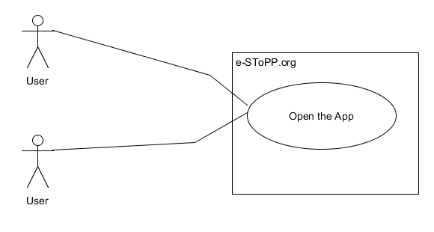

**Sequence Diagram**

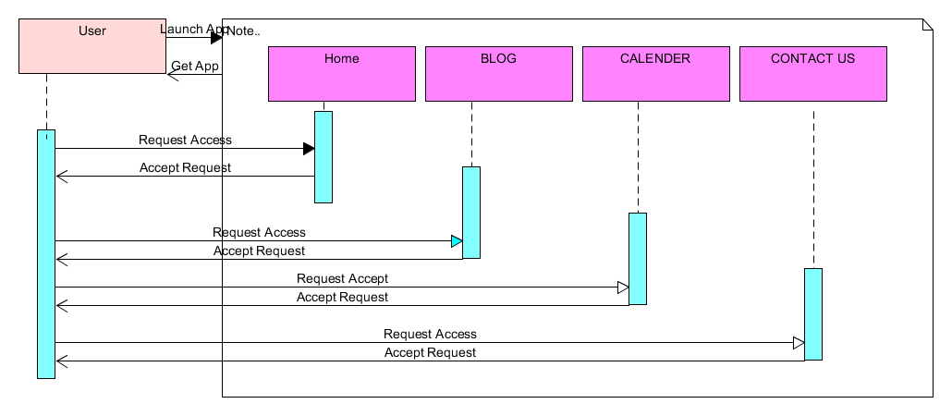

**Class Diagram**

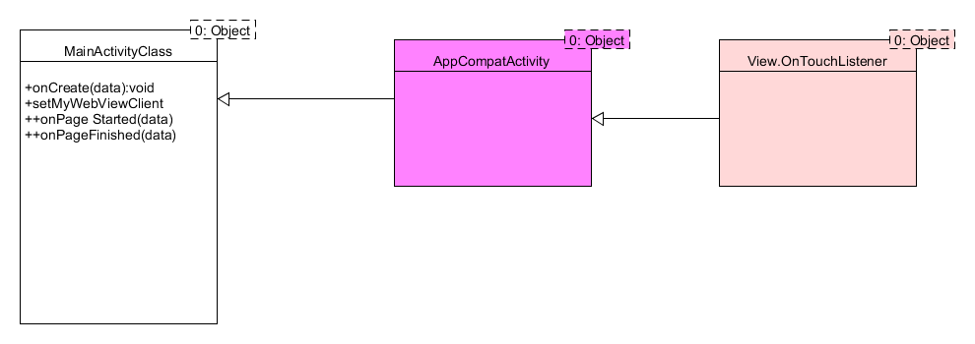

* **User Story# 123**

**Use Case Diagram ( Progress bar and output acceptance )**

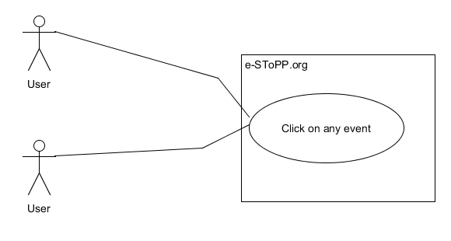

**Sequence Diagram ( Progress Bar and Access to Different Pages )**

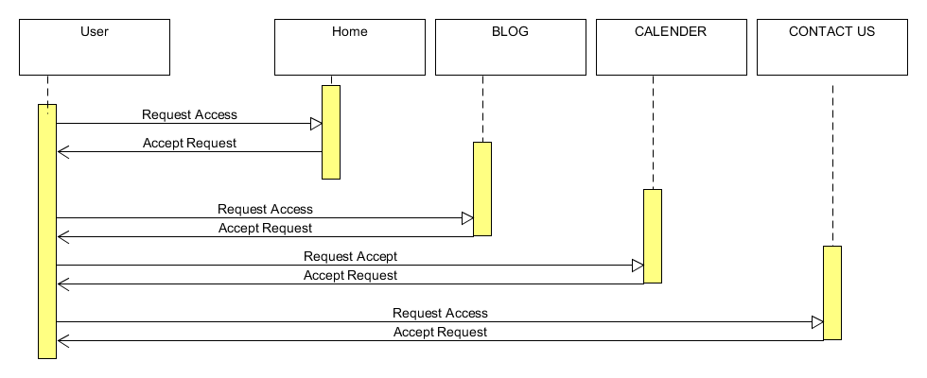

**Class Diagram**

## https://lh4.googleusercontent.com/yPBI6C3p0p8lsYL8-bERFh_O8gRrm3zAnsOV-OHiTqGlssXlqRmweBbiaSD9LL5Mqha4pqVYkFqNg9cWR0538NiejFZ_jLeYz3szHMWRyHa2kRqgYsYiO1o1Wo1REVC15eO4oYe0

## 

## User story# 124

**Diagram**

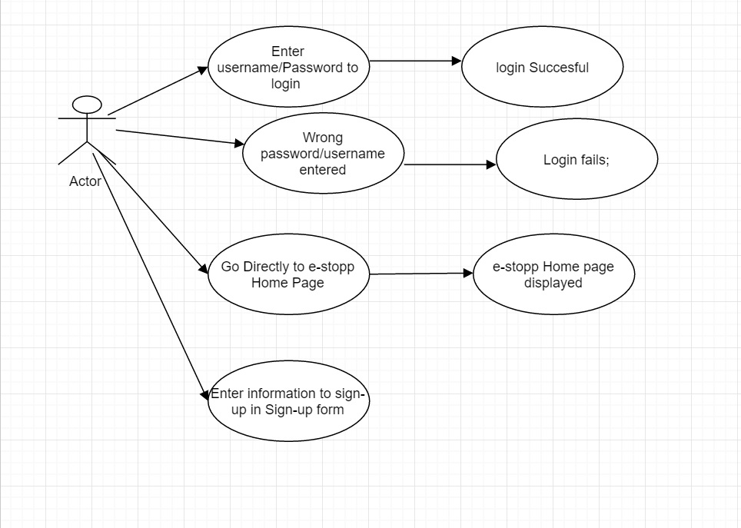

**Sequence Diagram**   
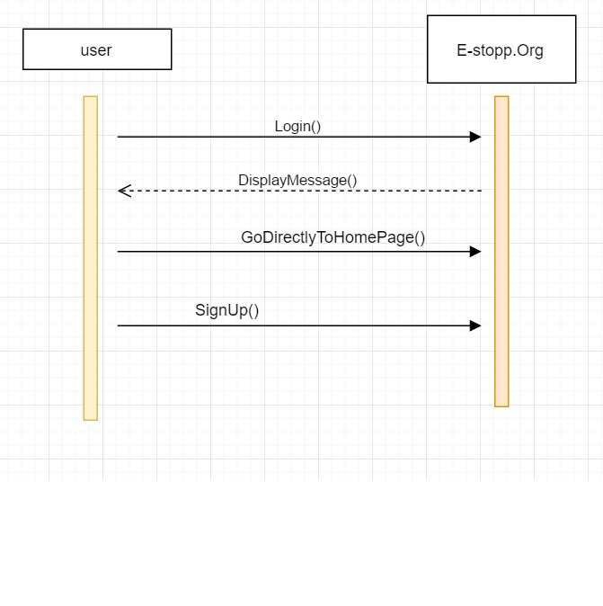

**Class Diagram**

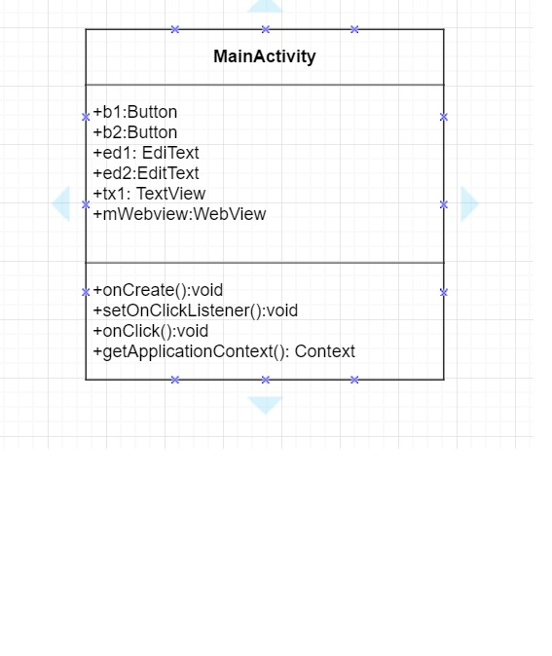

## User story# 125

**Sequence Diagram**

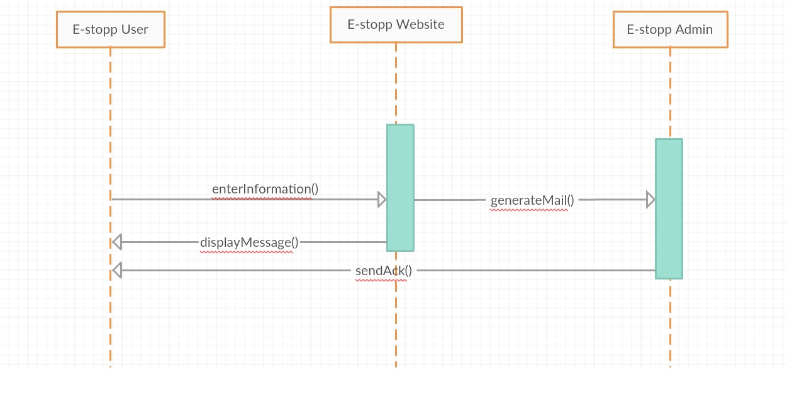

**Class Diagram**

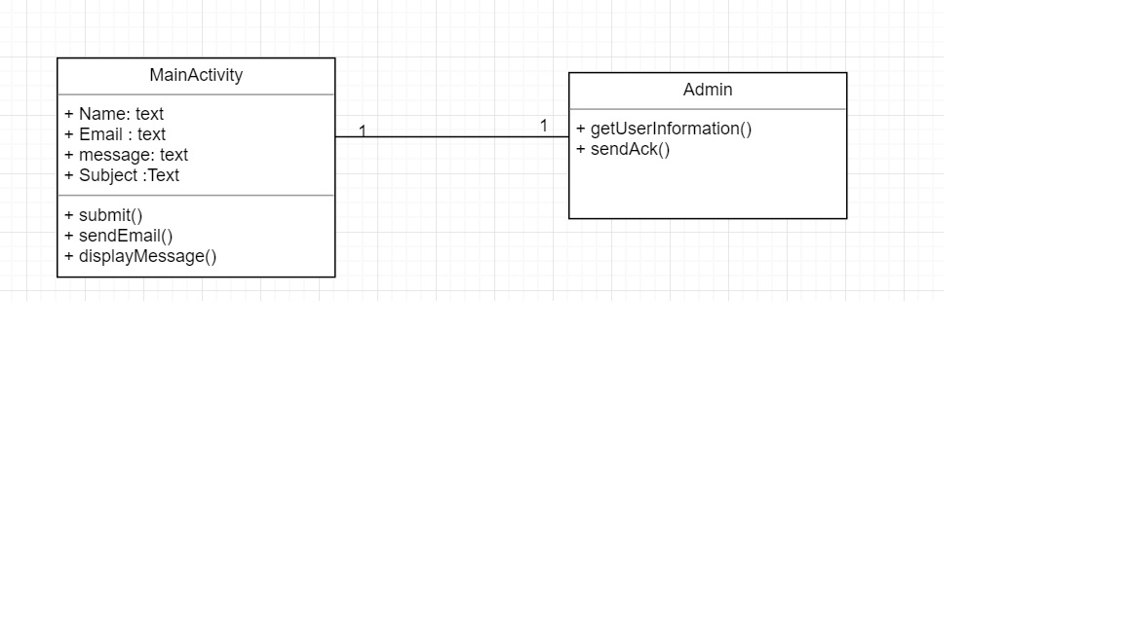

* **User Story# 126**

**Use Case Diagram ( Progress bar and output acceptance )**

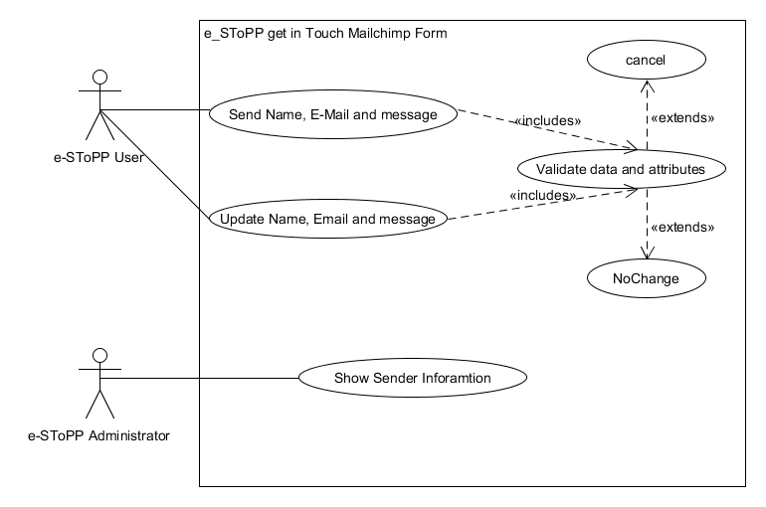

**Sequence Diagram ( Progress Bar and Access to Different Pages )**

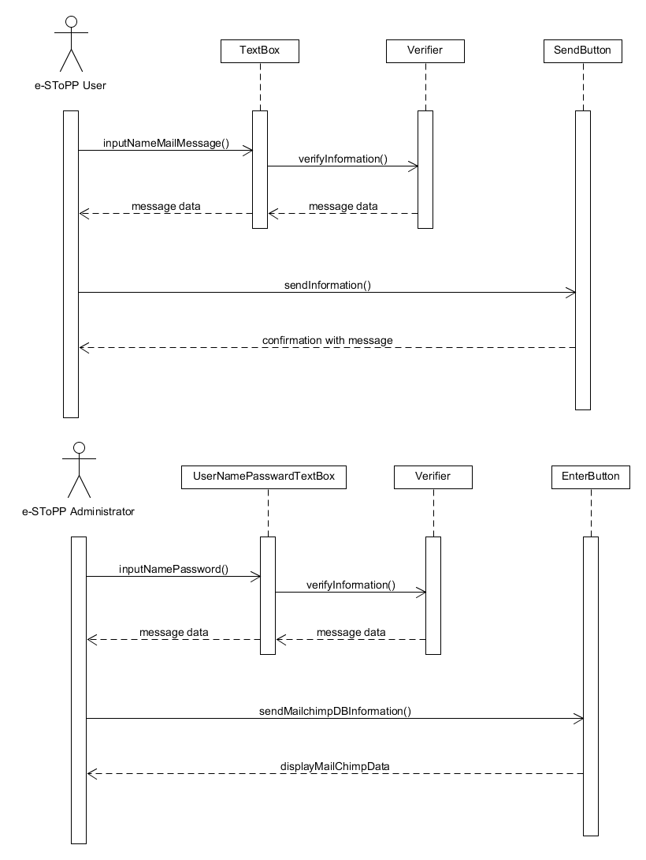**Class Diagram**

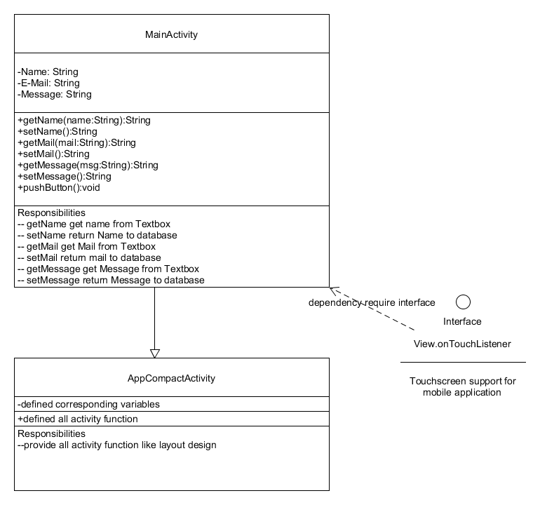

* **User story# 127**

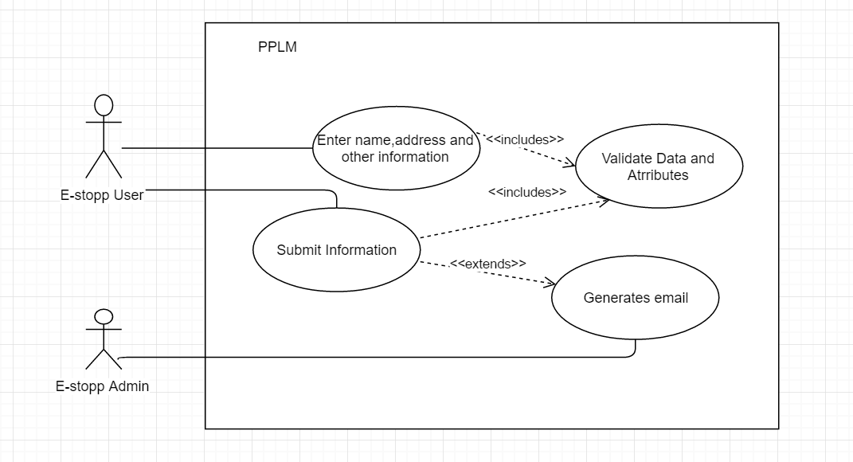

**Sequence Diagram**

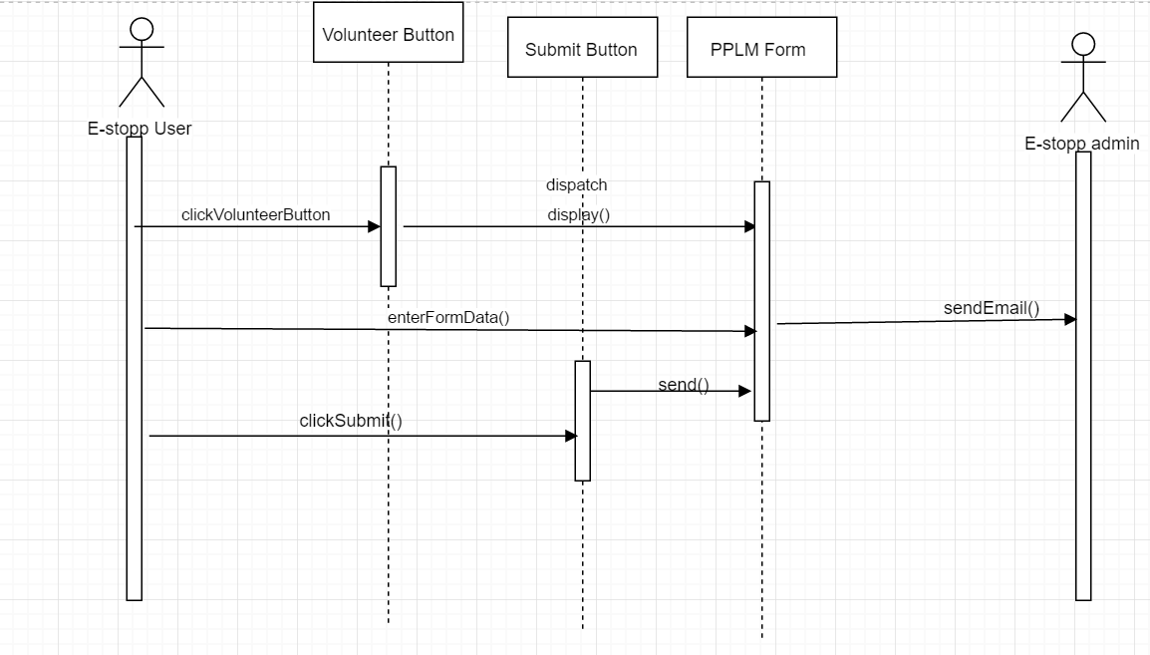

**Class Diagram**

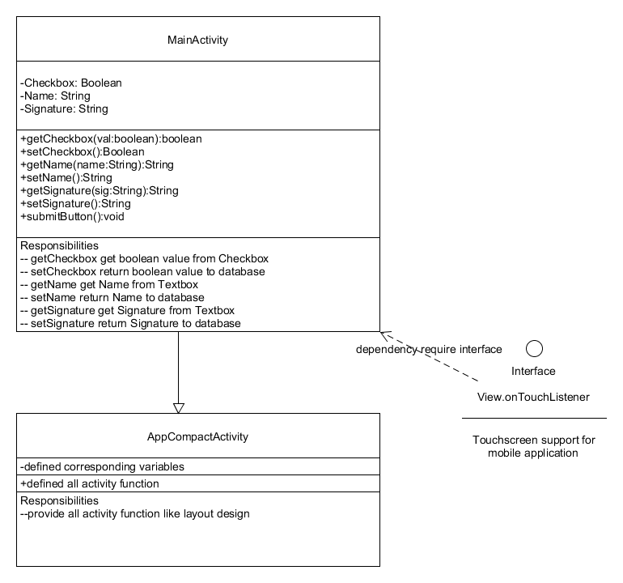

* **User story# 128**

**Use Case Diagram**

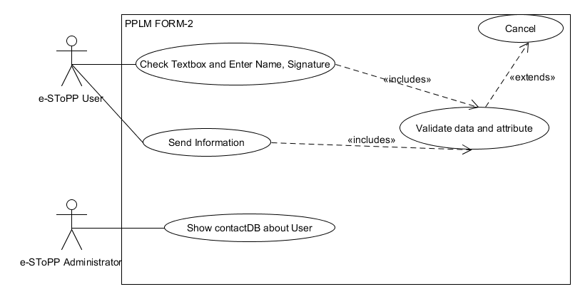

**Sequence Diagram**

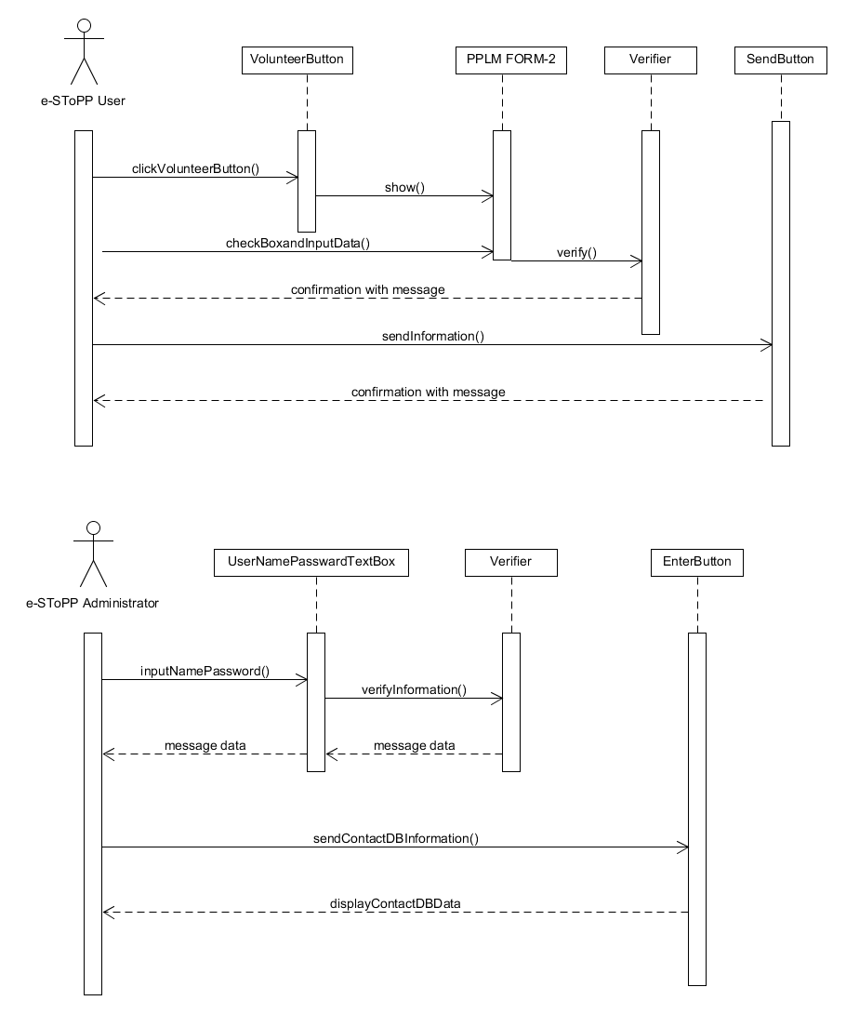  
**Class Diagram**



* **User Story #129**

**Use Case Diagram**

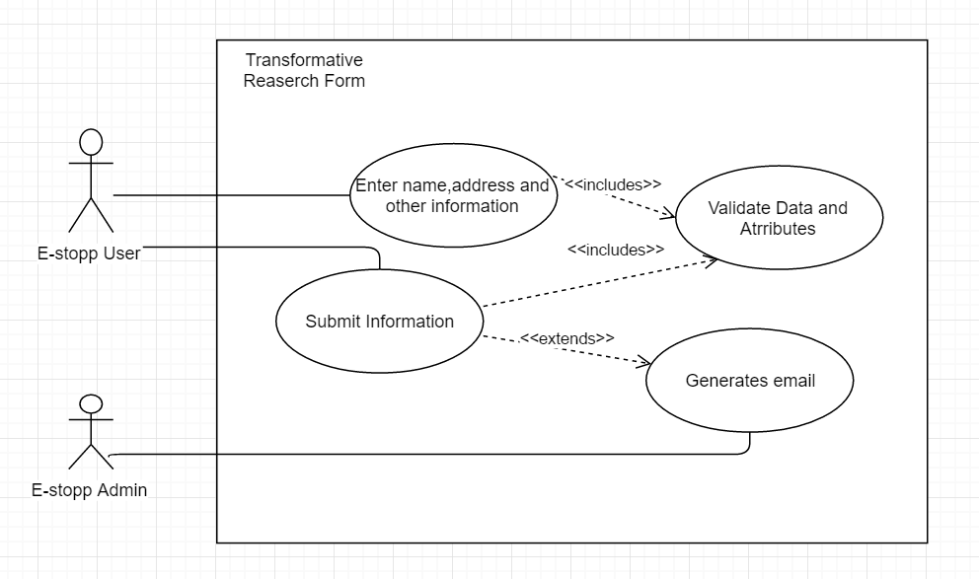

**Sequence Diagram**

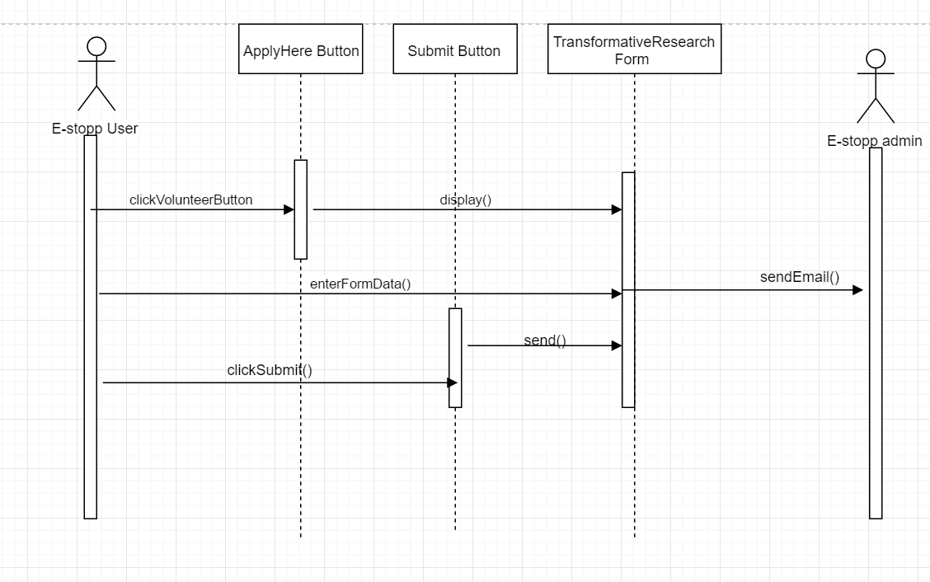

**Class Diagram**

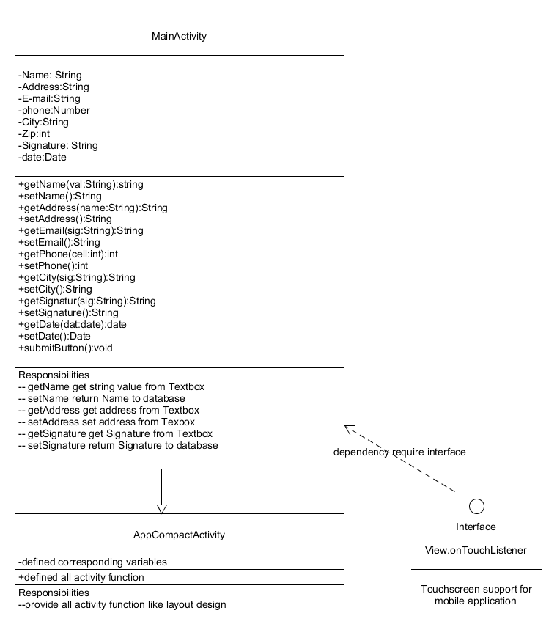

* **User story# 130**

**Use Case Diagram**

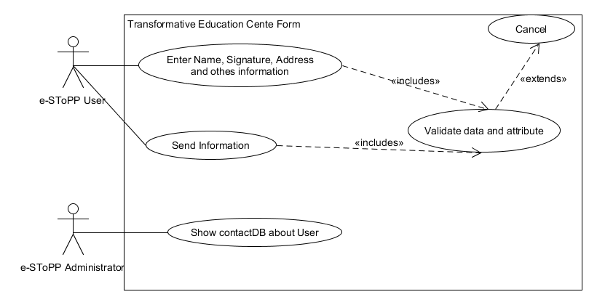

**Sequence Diagram**

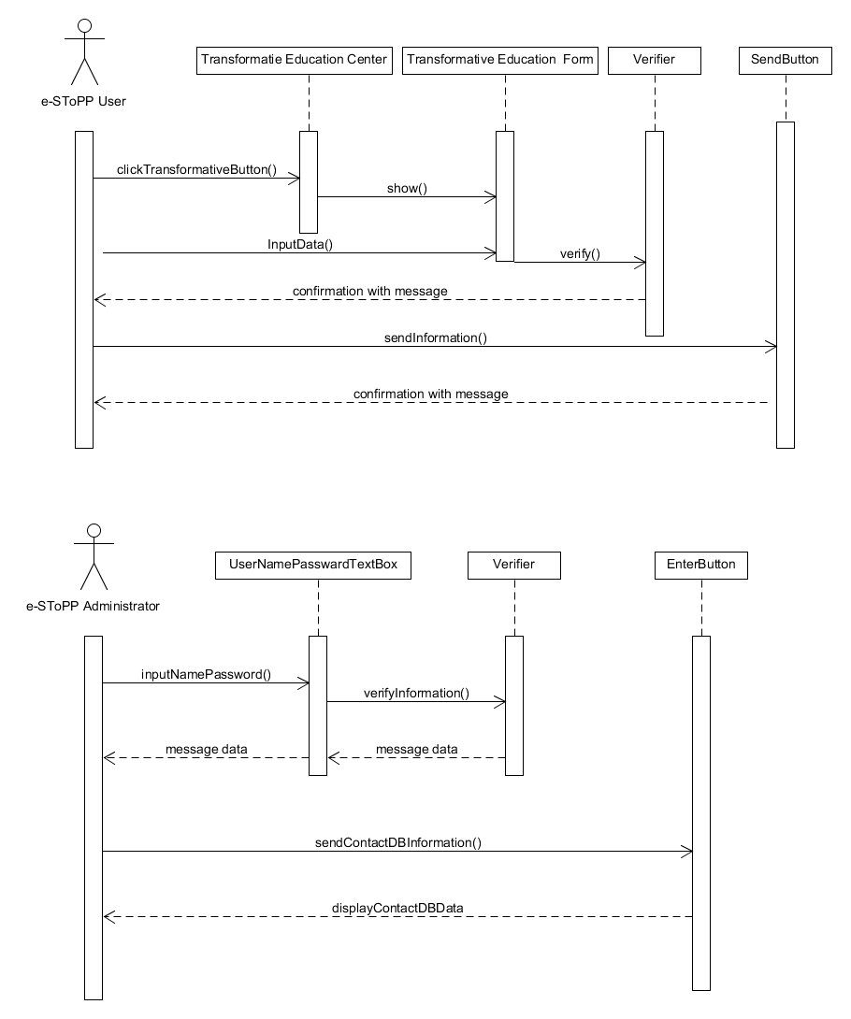**Class Diagram**



* **User Story #131**

**Use Case Diagram** 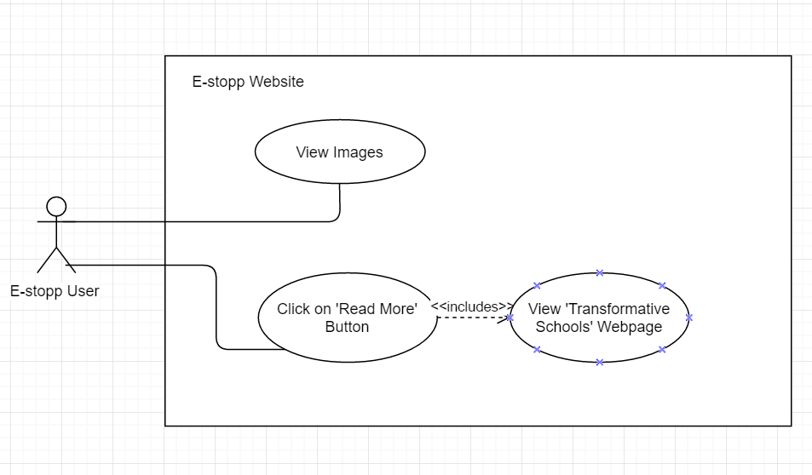

**Sequence Diagram**

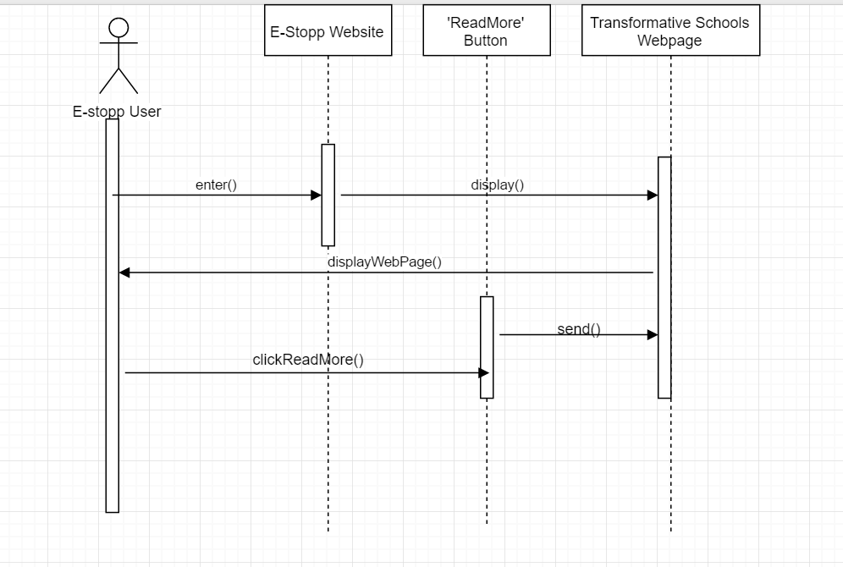

**Class Diagram**

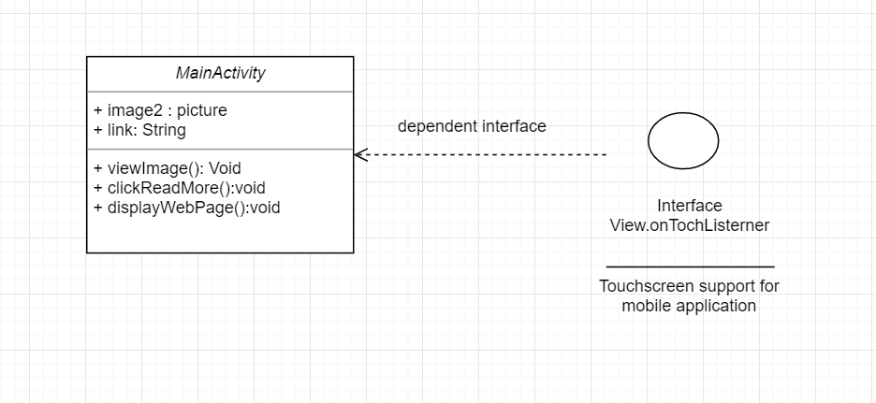

* **User story# 132**

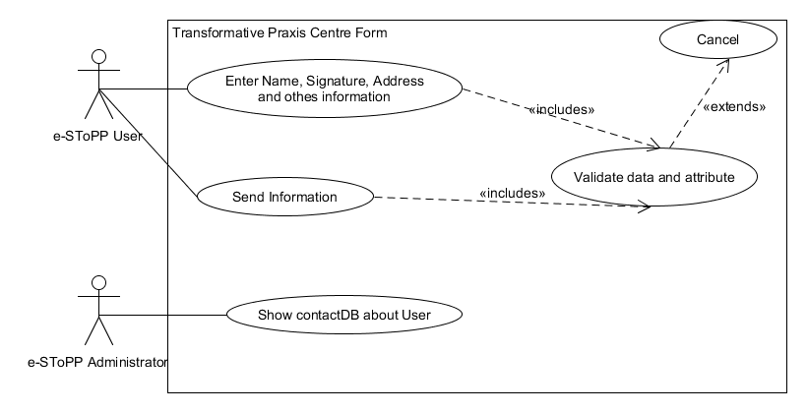

**Sequence Diagram**

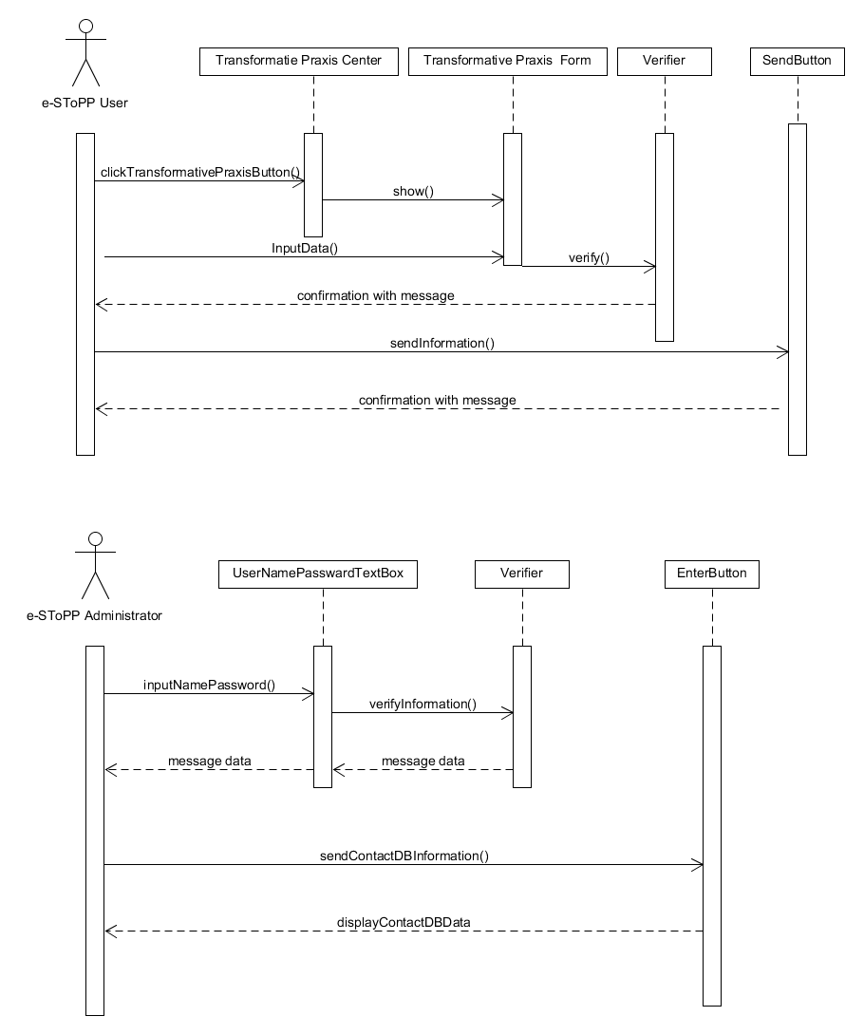  
  
**Class Diagram**



* User Story# 133

**Use Case Diagram**

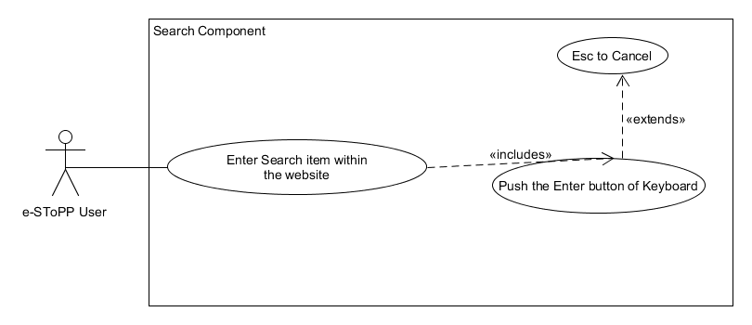

**Sequence Diagram**

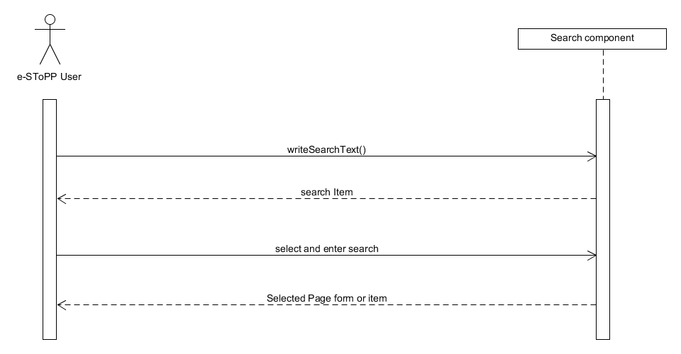

**Class Diagram**

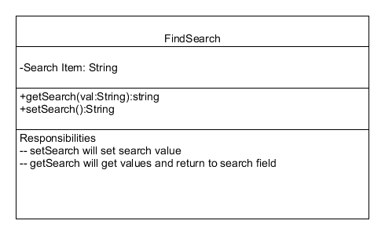

* **User Story #134**

**Use Case Diagram**

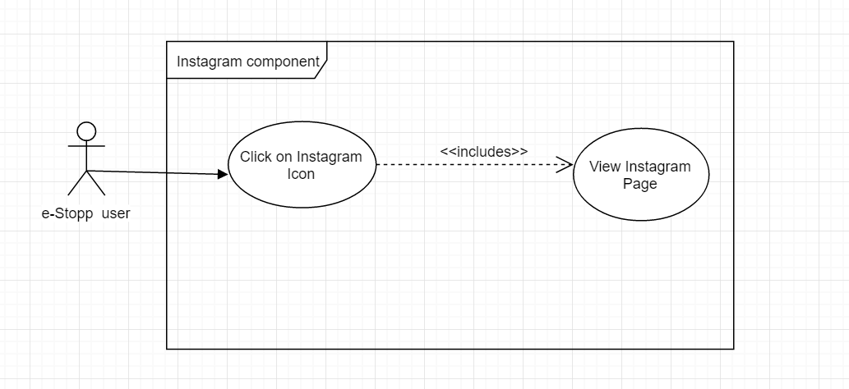

**Sequence Diagram**

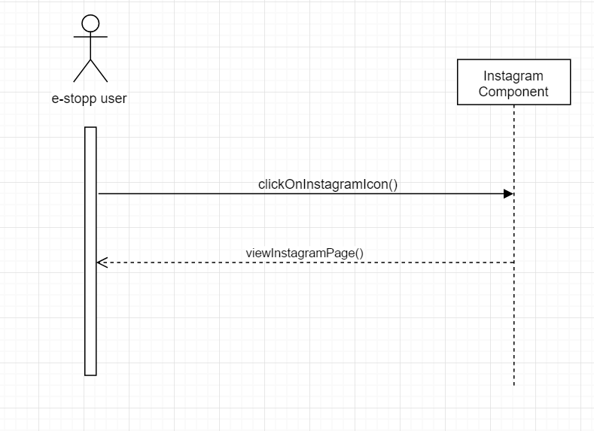

**Class Diagram**

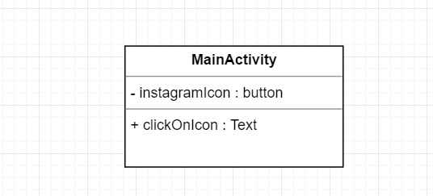

## Appendix B - User Interface Design

* **User Story# 120**

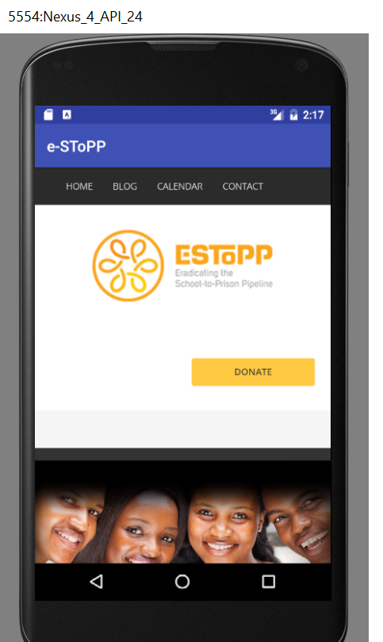

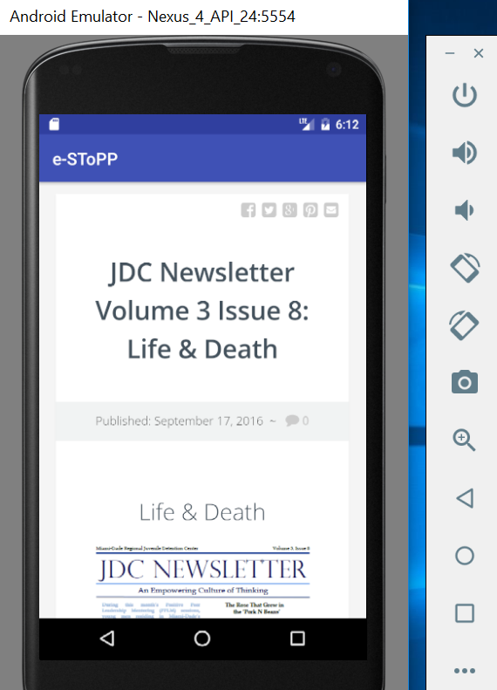

* **User Story #121**

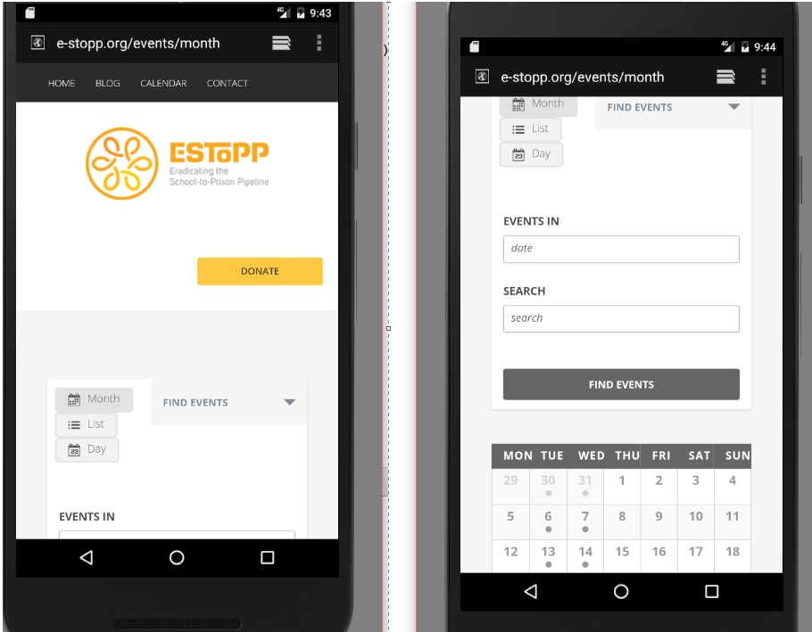

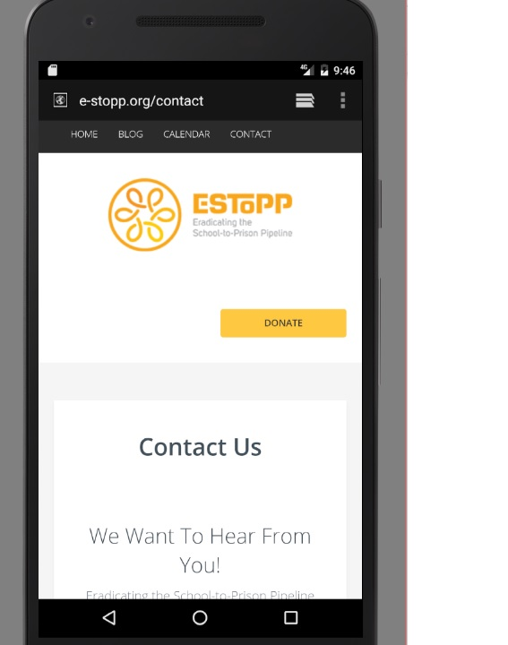

## 

* **User story #123**

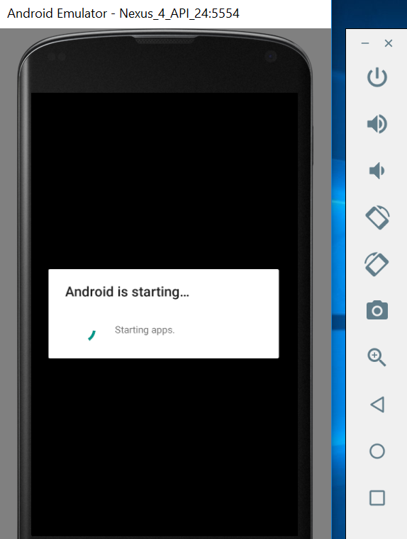

## 

## login.jpgUser Story 125

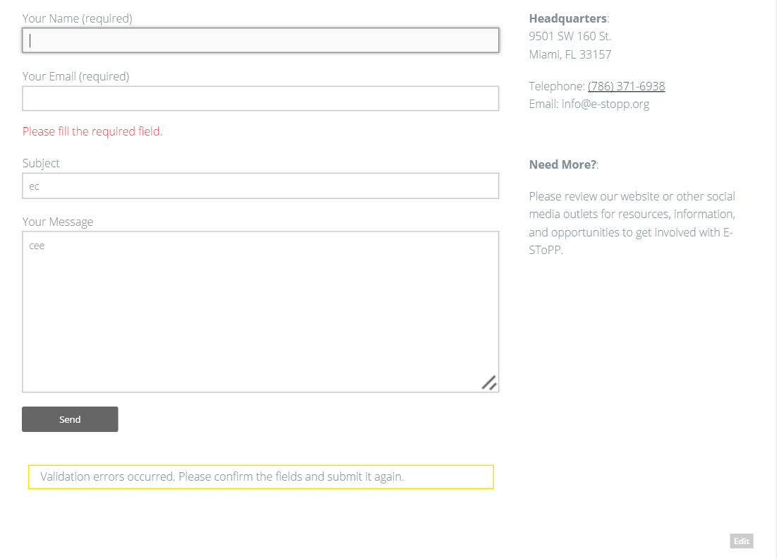

2. Once we enter information on android app.

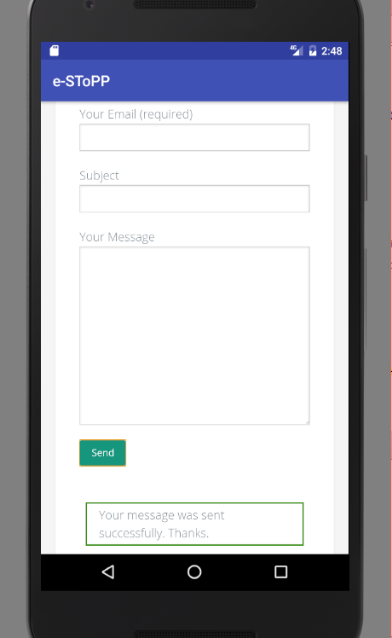

* **User Story 126**

1. In the e-SToPP website you can see the following JOIN THE E-STOPP MAILING LIST
2. Whenever you put Name, e-mail and message and click send then it will go to e-SToPP admin mail and store in e-SToPP.org and mailchimp repository.

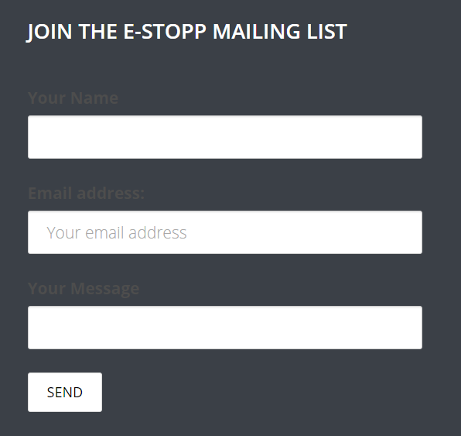

* **User Story 127**

2. Once we click on ‘Volunteer with us’ image on android app.

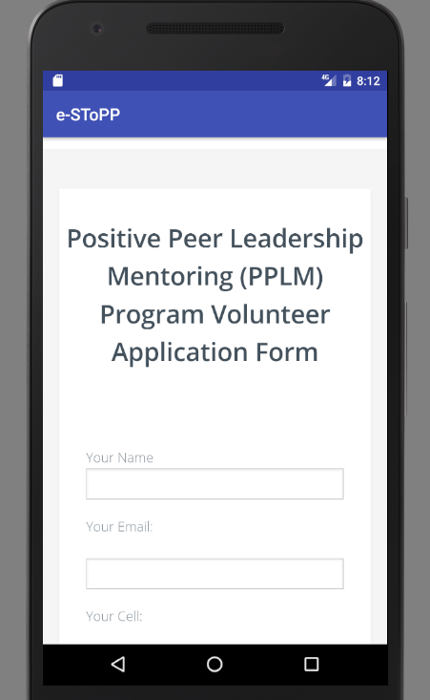

User story 128

2. When we check the contact form db it looks like this:

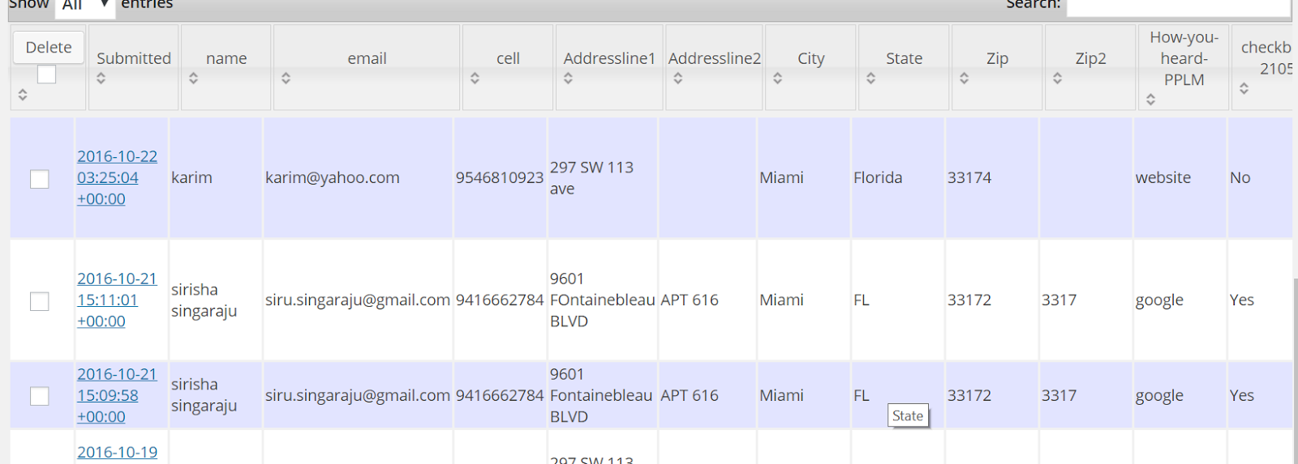

When you see it in mobile application it looks like this:

User Story 129

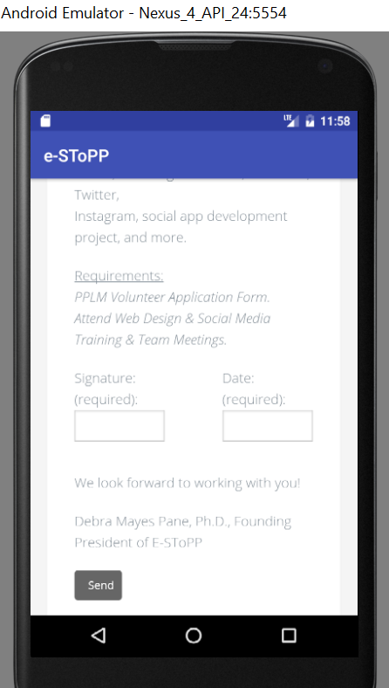

3. When you see it in mobile application it looks like this:

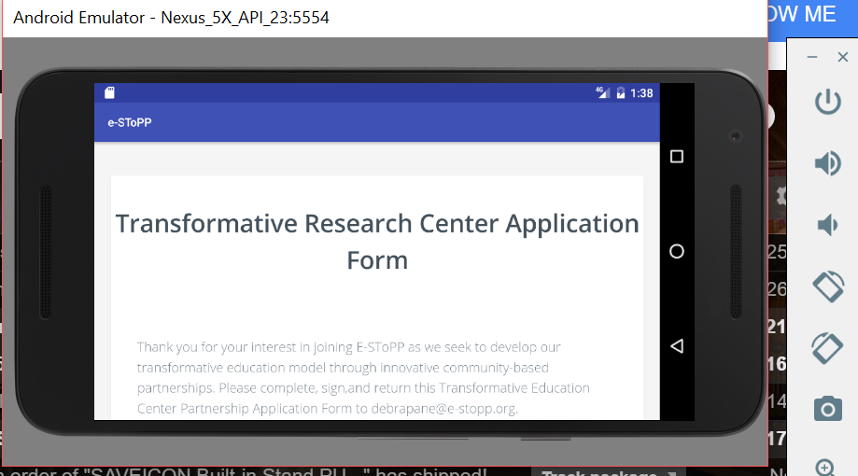

User Story 130

2. When we check the contact form db it looks like this:

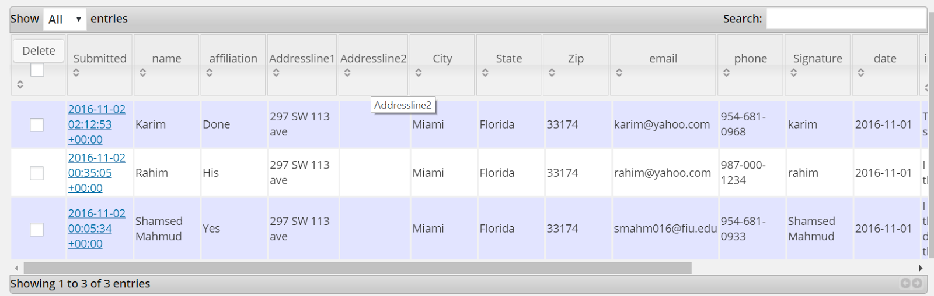

3. When you see it in mobile application it looks like this:

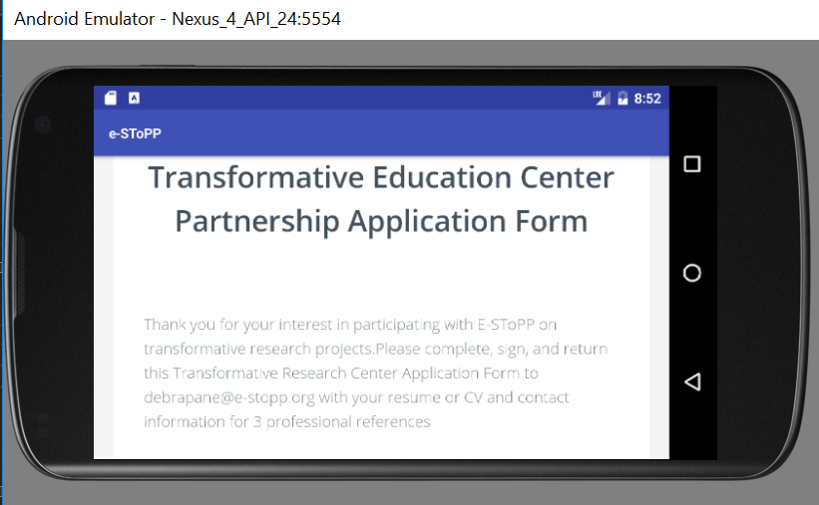

User Story 131

3. When you see it in mobile application it looks like this: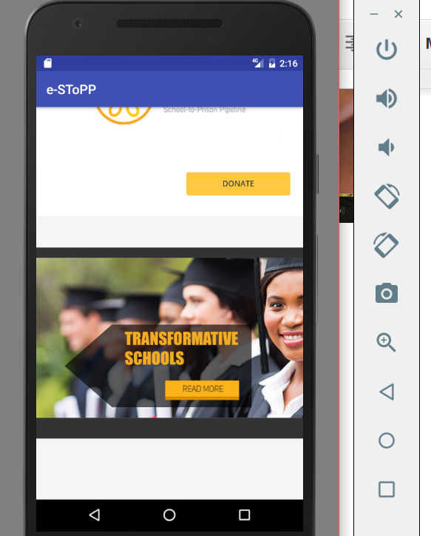

* **User Story 132**

2. When we check the contact form db it looks like this:

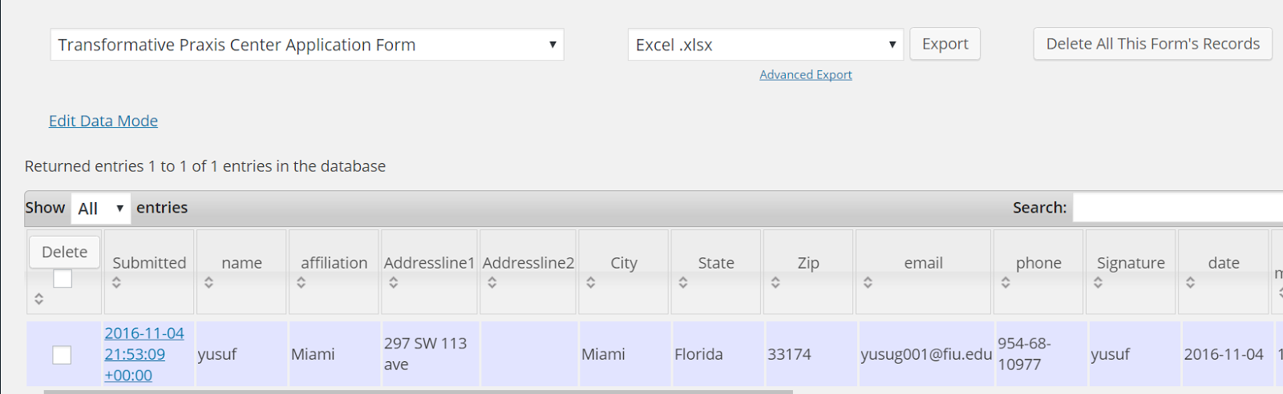

3. When you see it in mobile application it looks like this:

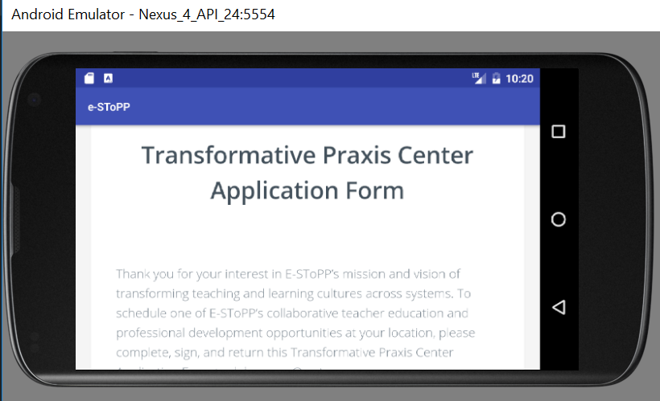

* **User Story 133**

1. Once we get enter into the website, then it should look like this:



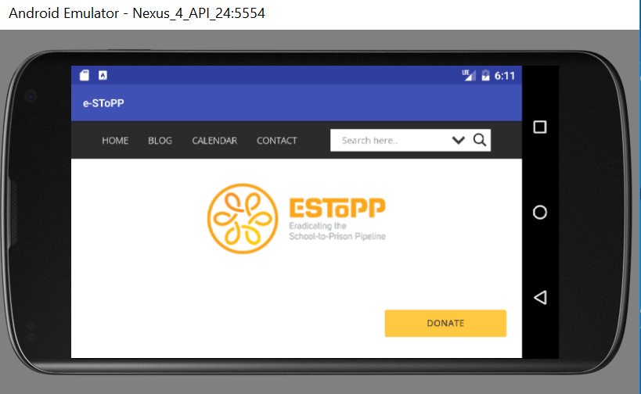

* **User Story 134**

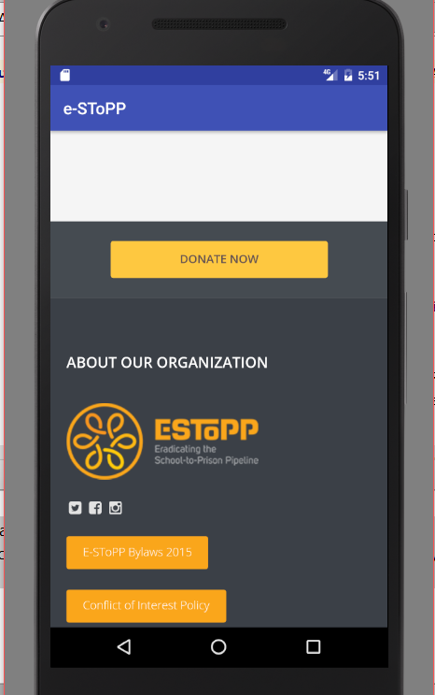

2. Once I get into the app then it would look like the below:

User Story 135



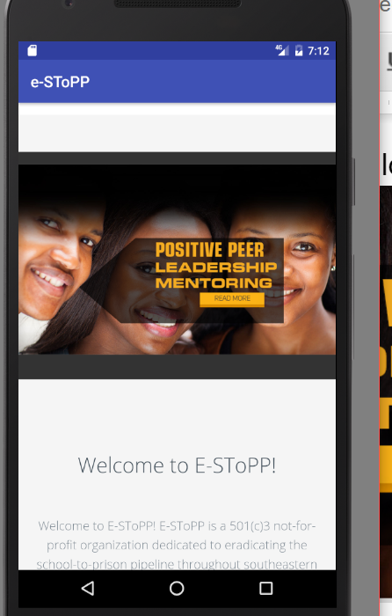

## Appendix C – Sprint Review

**Sprint 2**

Attendees: Rick Little, Shamsed Mahmud , Sirisha Singaraju

Start time: 09.09.2016 4:30 PM

End time: 09.09.2016  5:00 PM

After a show and tell presentation, the implementation of the following user stories were accepted by the product owners: All.

* User Story <120 ,Testing of Homepage and blog feature of App>
* User Story <121, Testing of Calender and Contact of App >
* User Story <122, Publish the App in the Google play center >
* User Story <123, Performance Enhancement and Add Progress bar feature in App >

Part All were done except User story <122,Publish the App in the Google play center > and we are working on it. It requires too much time to upload and it says some licensing issues.

The following ones were rejected and moved back to the product backlog to be assigned to a future sprint at a future Spring Planning meeting.

* User Story <122, Publish the App in the Google play center >
* How this should be reflected on the user story definition in Mingle:

As the task was given but the thing is that we could not publish in due time. So it is put in the backlog and hope to start in the next sprint with more studying. As it was a publishing task this task will not hamper the other task.

**Sprint 3**

Attendees: Rick Little, Shamsed Mahmud , Sirisha Singaraju

Start time: 09.29.2016 4:30 PM

End time: 09.29.2016  5:00 PM

After a show and tell presentation, the implementation of the following user stories were accepted by the product owners: All.

* User Story <125> Add email functionality to contact us page of e-stopp website
* User Story <126> Add new ‘get in touch’ using the mailchimp plugin

The following ones were rejected and moved back to the product backlog to be assigned to a future sprint at a future Spring Planning meeting.

* User Story <122, Publish the App in the Google play center >
* How this should be reflected on the user story definition in Mingle:

As the task was given but the we do not still have access to google play, and hence we could not publish in due time. So it is put in the backlog and hope to start in the next sprint .As it was a publishing task this task will not hamper the other task.

**Sprint 4**

Attendees: Rick Little, Shamsed Mahmud , Sirisha Singaraju

Start time: 10.11.2016 4:30 PM

End time: 10.11.2016  5:00 PM

After a show and tell presentation, the implementation of the following user stories were accepted by the product owners: All.

* User Story <127> Convert the Volunteer Application Form in Interactive Website with Wordpress-1(Page 1&2)
* User Story <128> Convert the Volunteer Application Form in Interactive Website with Wordpress-2(Page 3&4)

N.B: This time we do not have any remaining task

The following ones were rejected and moved back to the product backlog to be assigned to a future sprint at a future Spring Planning meeting.

* User Story <122 Publish the app in google play>
* How this should be reflected on the user story definition in Mingle:

As the task was given to us  but our product owner decided to upload by himself. So he has already uploaded the task but it is already running and not upload yet.

**Sprint 5**

Attendees: Rick Little, Shamsed Mahmud , Sirisha Singaraju

Start time: 10.24.2016 4:30 PM

End time: 10.24.2016  5:00 PM

After a show and present presentation, the implementation of the following user stories were accepted by the product owners: All.

* User Story <129> Convert the pdf of Transformative Research form in e-StoPP website to responsive website and convert to mobile application.
* User Story <130> Convert the pdf of Transformative Education center form in e-StoPP website to a responsive website and convert to mobile application.
* User Story <131> Add a new 'Transformative Schools' Image with graphics and animation for the main Banner for e-Stopp Website.
* User Story <132> Convert the pdf of Trans-formative Praxis center form in e-StoPP website to a responsive website and convert to mobile application.

N.B: This time we do not have any remaining task

The following ones were rejected and moved back to the product backlog to be assigned to a future sprint at a future Spring Planning meeting.

* User Story <122 Publish the app in google play>
* This task is in Beta testing phase.
* How this should be reflected on the user story definition in Mingle:

As the task was given to us  but our product owner decided to upload by himself. So he has already uploaded the task but it is already running and alpha testing task phase.

**Sprint 6**

Attendees: Rick Little, Shamsed Mahmud , Sirisha Singaraju

Start time: 11.18.2016 4:30 PM

End time: 11.18.2016  5:00 PM

After a show and present presentation, the implementation of the following user stories were accepted by the product owners: All.

* User Story <133> Adding AJAX powered Search Lite to the e-Stopp website.
* User Story <134> Adding Instagram icon and linking the account to the Website
* User Story <135> Add a new 'Positive Peers' Image with graphics and animation for the main Banner for e-Stopp Website
* User Story <136> Add a new MailChimp Account, Import Data and a Campaign for e-stopp website

This time we have only remaining task

* User Story <122 Publish the app in google play>
* This task is in Beta testing phase. Both Sirisha and Rick are using it and testing it. Once the product owner confirms , it will be immediately moved to production.

.

**Sprint 7**

Attendees: Mohsen Taheri, Shamsed Mahmud , Sirisha Singaraju

Start time: 11.18.2016 4:30 PM

End time: 11.18.2016  5:00 PM

After a show and present presentation, the implementation of the following user stories were accepted by the product owners: All.

* User Story <137> Create Poster and Documentation of the Project
* User Story <138> Create Poster and Documentation of the Project

## Appendix D – Sprint Retrospective meeting

**Sprint 1**

Attendees: Rick Little, Shamsed Mahmud , Sirisha Singaraju

Start time: 09.09.2016 11:00 AM

End time: 09.09.2016  12:10 PM

What went wrong?

* Did we do a good job estimating our team's velocity?
  + We did not understand the job volume
* Did we do a good job estimating the points (time required) for each user story?
  + As it is our first task we did not do the correct estimating point
* Did each team member work as scheduled?
  + Team member worked but as it is learning a new platform we can not complete the task and we worked more than the scheduled task.

What went right?

* Even Though, the segregation of  the job is not right our decision to work in this way was right

How to address the issues in the next sprint?

* How to improve the process?
  + We hope after the next sprint we will segregate the task more slicing and feasible to do in due time.
* How to improve the product?
* Standard coding and implementation of the complex task would help us to improve the rask.

**Sprint 2**

Attendees: Rick Little, Shamsed Mahmud , Sirisha Singaraju

Start time: 09.09.2016 4:00 PM

End time: 09.09.2016  4:30 PM

What went wrong?

* Did we do a good job estimating our team's velocity?
  + We estimate the job velocity and it is 40
* Did we do a good job estimating the points (time required) for each user story?
  + Some task are big even though we try to implement it
* Did each team member work as scheduled?
  + In this sprint we are working in due time

What went right?

* Job distribution is relatively big

How to address the issues in the next sprint?

* How to improve the process?
  + We hope after the next sprint we will segregate our task well
* How to improve the product?
* Standard coding and implementation of testing and add some new feature will make it smart one.

**Sprint 3**

Attendees: Rick Little, Shamsed Mahmud , Sirisha Singaraju

Start time: 09.29.2016 4:00 PM

End time: 09.29.2016  4:30 PM

What went wrong?

* Did we do a good job estimating our team's velocity?
  + We estimate the job velocity  to be 40
* Did we do a good job estimating the points (time required) for each user story?
  + Yes all task were completed on time.
* Did each team member work as scheduled?
  + Both team members are working as per schedule. The project is in good shape

What went right?

* Distribution of task, time spent on research since we have to work on wordpress and mailchimp in this sprint

How to address the issues in the next sprint?

* How to improve the process?
  + We need more communication with our product owner .
* How to improve the product?
* We will be performing more testing and research on ways to improve performance

**Sprint 4**

Attendees: Rick Little, Shamsed Mahmud , Sirisha Singaraju

Start time: 10.11.2016 4:00 PM

End time: 10.11.2016  4:30 PM

What went wrong?

* Did we do a good job estimating our team's velocity?
  + We estimate the job velocity  to be 40
* Did we do a good job estimating the points (time required) for each user story?
  + Yes all task were completed on time.
* Did each team member work as scheduled?
  + Both team members are working as per schedule. The project is in good shape

What went right?

* Distribution of task, time spent on research since we have to work on wordpress and mobile application conversion in this sprint 4.

How to address the issues in the next sprint?

* How to improve the process?
  + We need more communication with our product owner .
* How to improve the product?
* We will be performing more testing and research on ways to improve performance

**Sprint 5**

Attendees: Rick Little, Shamsed Mahmud , Sirisha Singaraju

Start time: 10.24.2016 4:00 PM

End time: 10.24.2016  4:30 PM

What went wrong?

* Did we do a good job estimating our team's velocity?
  + We estimate the job velocity  to be 40
* Did we do a good job estimating the points (time required) for each user story?
  + Yes all task were completed on time.
* Did each team member work as scheduled?
  + Both team members are working as per schedule. The project is in good shape

What went right?

* Distribution of task, time spent on research since we have to work on wordpress and mobile application conversion in this sprint 5.

How to address the issues in the next sprint?

* How to improve the process?
  + We need more communication with our product owner .
* How to improve the product?
* We will be performing more testing and research on ways to improve performance

**Sprint 6**

Attendees: Mohsen Taheri, Shamsed Mahmud , Sirisha Singaraju

Start time: 11.18.2016 4:00 PM

End time: 11.18.2016  4:30 PM

What went wrong?

* Did we do a good job estimating our team's velocity?
  + We estimate the job velocity  to be 40
* Did we do a good job estimating the points (time required) for each user story?
  + Yes all task were completed on time.
* Did each team member work as scheduled?
  + Both team members are working as per schedule. The project is in good shape

What went right?

* Distribution of task, time spent on research since we have to work on wordpress and mobile application conversion in this too.

How to address the issues in the next sprint?

* How to improve the process?
  + We need productive communication with our product owner .
* How to improve the product?
* We will be performing more testing and research on ways to improve performance

**Sprint 7**

Attendees: Mohsen Taheri, Shamsed Mahmud , Sirisha Singaraju

Start time: 11.30.2016 4:00 PM

End time: 11.30.2016  4:30 PM

What went wrong?

* Did we do a good job estimating our team's velocity?
  + We estimate the job velocity  to be 40
* Did we do a good job estimating the points (time required) for each user story?
  + Yes all task were completed on time.
* Did each team member work as scheduled?
  + Both team members are working as per schedule. The project is in good shape

What went right?

* Distribution of task, time spent on research since we have to work on wordpress and mobile application conversion in this too.

How to address the issues in the next sprint?

* How to improve the process?
  + We need productive communication with our product owner .
* How to improve the product?
* We will be performing more testing and research on ways to improve performance

# References

* 1. [www.android.com](http://www.android.com)
  2. <http://php.net/>
  3. <https://wordpress.com/>
  4. <http://www.oracle.com/technetwork/articles/java/index-jsp-135444.html>